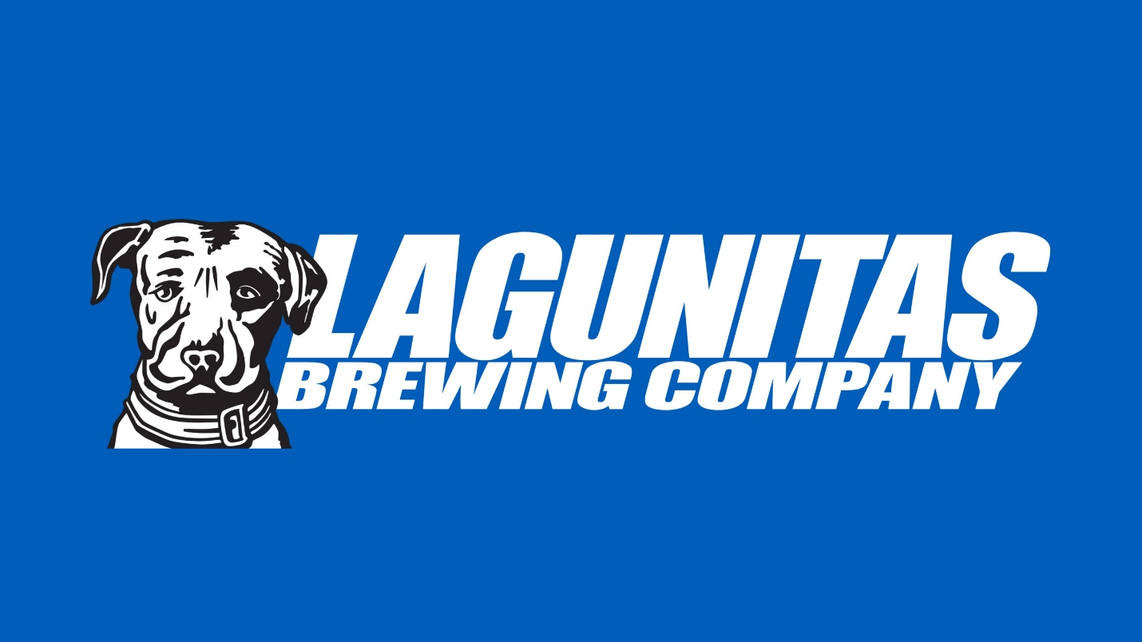

CRM 2 User Guide

Table of Contents

User Guide Overview 4

App Layout 5

App Access (Appcess?) 6

Downloading the New CRM 6

App Login 8

On The Call 9

The Distributors Page 9

Search and Navigation 10

Favorites 12

Nearby 14

Distributors 14

Distributor Account List 15

Accessing the Account List 15

Account List Overview 17

Account Overview 39

Accessing the Account Overview 39

Account Visits 46

Entering New Visits 46

Accessing Past Visits 58

My Stuff 59

Lagunator Scorecard 60

Changing Scorecard Timeframes 61

Recent Visits 64

Recent Placements 67

High Five 68

Distributor Communication 69

Selecting the Active Distributor 70

Scorecards + YTD Numbers 71

Recent Visits 71

Action Items 74

The Action Items Header Bar 75

The Action Items List 77

Marketing 79

Off-site Event/Sponsorship Request Form 80

Brewery Request Form 80

Sell Sheets and Virtual Tastes 82

Lagunitas Schwag 83

Control Panel 85

Help Desk 85

Logout 86

# User Guide Overview

Welcome to the Lagunitas CRM brain-transfer knowledge dump. It’s a heap.

Of information!

We’ve got a lot to cover in a short amount of time, so let’s get right to it. This document will serve as your guide on the journey that is our new CRM (it’s sort of like the light of Eärendil, if you get my meaning).

What’s important to remember is that this whole thing isn’t as hard as it looks, and if you’ve used the previous version of the CRM, it’ll be like slipping on a new pair of your favorite shoes. If you’ve never used the CRM before, then congratulations! You just got a new pair of shoes.

Without further a-do, let’s get to it.

Come on in, the water’s warm and the beer is cold!

## App Layout



The CRM2 app is broken into 5 sections:

* On The Call
* My Stuff
* Distributor Communication (Dist Commun)
* Marketing
* Control Panel

We’ll go through each of these sections in turn. Some of it pretty stock-standard as it was before, while there are some pretty nifty redesigns and overhauls as well.

# App Access (Appcess?)

This section will cover installing and logging into the CRM2 iOS app.

## Downloading the New CRM

To download the new CRM app, first open App Updates on your iOS device.

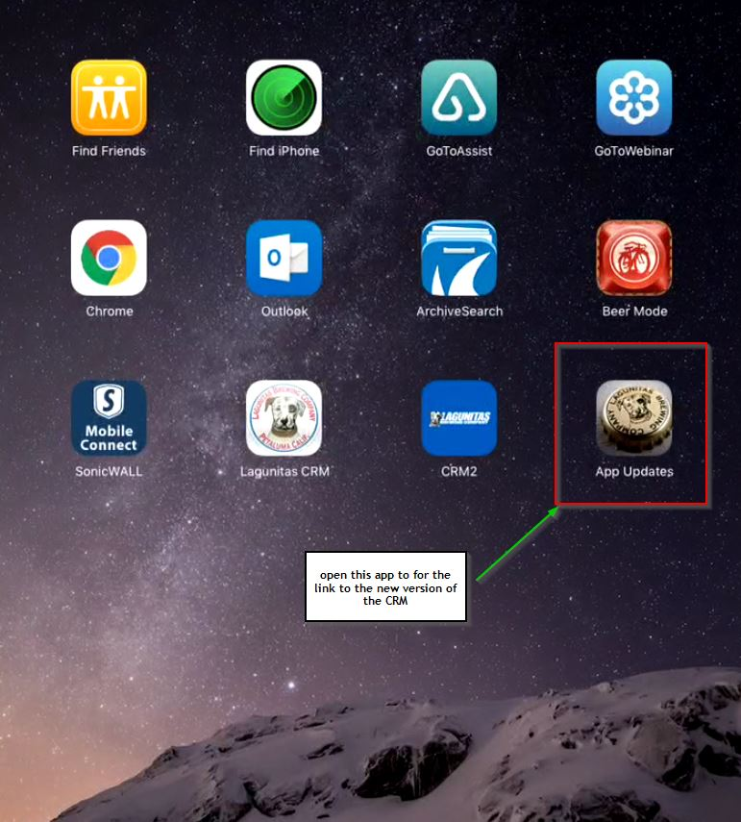

This will lead you to the MobileIron webpage (sort of like our internal appstore), where you will see a link to install the CRM2 app. Pressing this link will install the latest version of the CRM2 app onto your iPad.

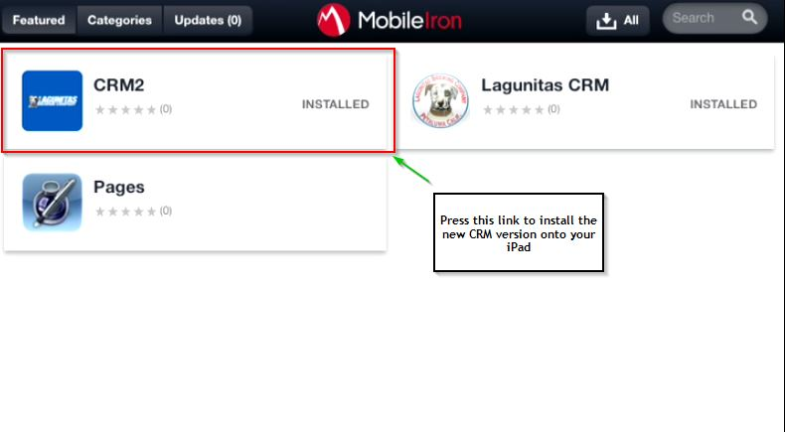

Once the install is finished, you will see the (soon-to-be famous) blue CRM2 icon on your device. Nothing to it.

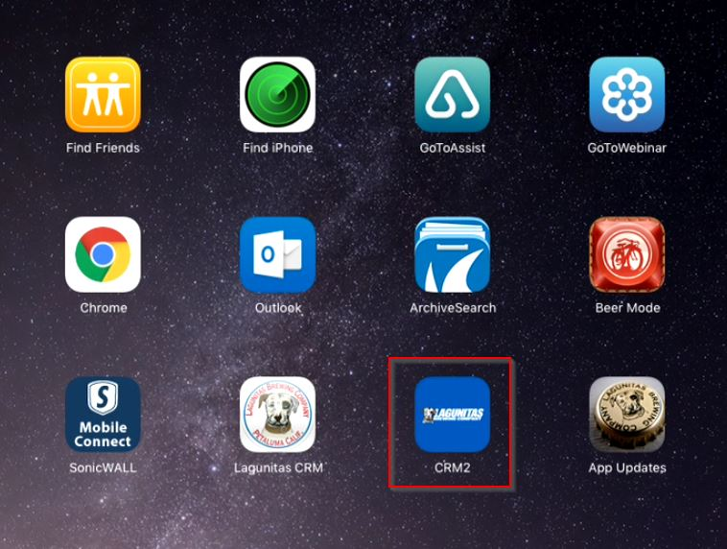

## App Login

Logging into the app is as easy as logging into your work computer – in fact, you’ll be using the same username and password! Technology, right?

First, press the blue CRM2 icon to launch the app. This will bring you to the login page.

Use the same username and password as your work computer to log in to CRM2.

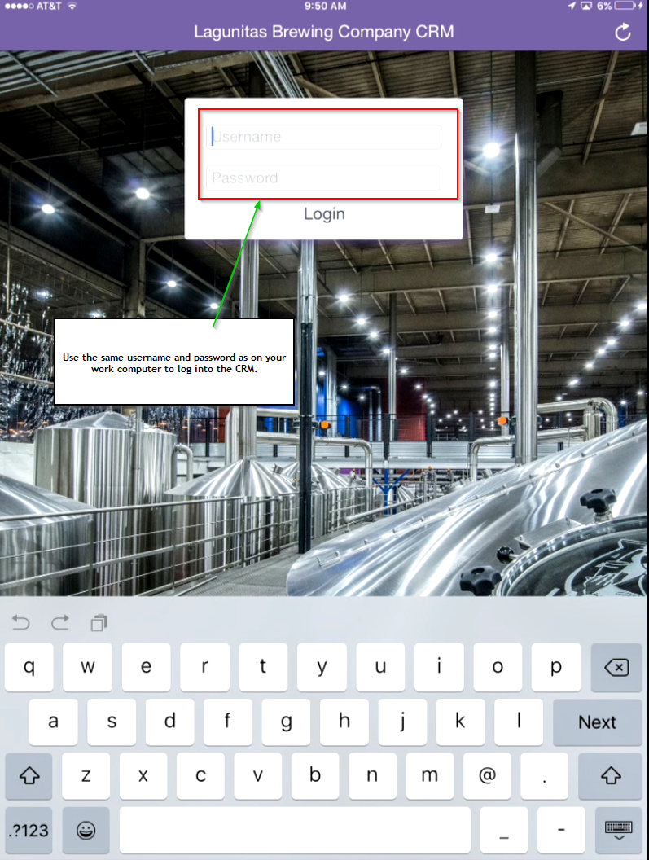

After entering your username/password, either press “Login” in the box above or the blue “Go” button on your keyboard. Et voila! C'est Magnifique!

# On The Call



This tab is where you’ll be spending most of your time. If you don’t believe me, then…well, you don’t believe me. But you should. So listen up!

## The Distributors Page

The On The Call tab starts with the Distributors page, which is broken up into four main sections:

1. Search and Navigation
2. Favorited Distributors
3. Nearby Distributors
4. All Distributors

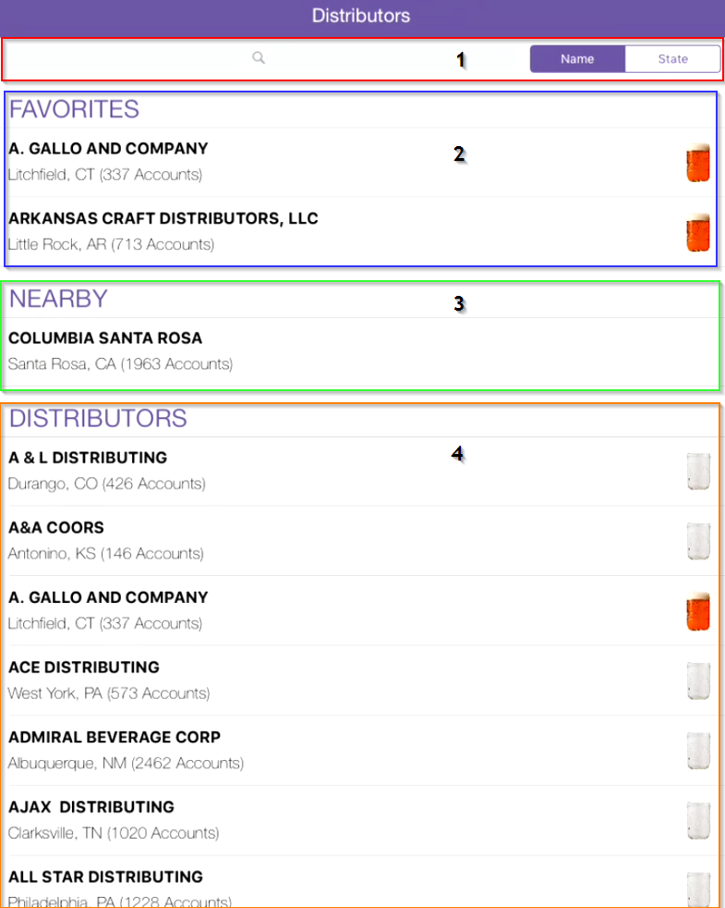

We’ll go over each of these in detail.

### Search and Navigation

The search bar allows you to narrow down the list of distributors displayed. To use this feature, simply enter the search bar and start typing the name of the desired distributor:

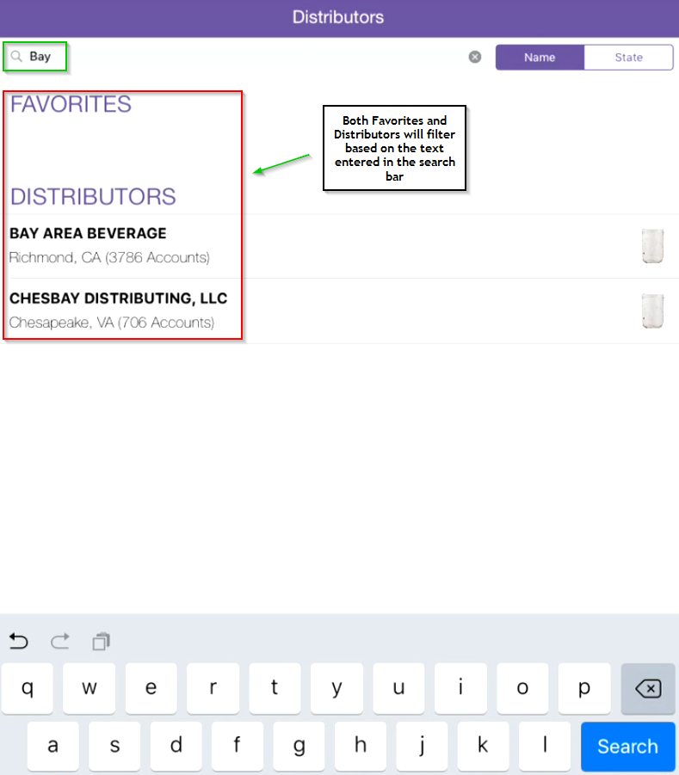

The list of distributors shown in both the Distributors section and the Favorites section will refine based on the text entered in the search bar; the Favorites section will go blank if the search text does not match any favorited distributors.

#### Name

This is the default format for displaying distributors; that is, in alphabetical order by distributor name. To split up distributors by state, the user must press the State button.

#### State

To break distributor results up by state, press the State button. This will cause an alphabetically arranged state list to appear, with the number of distributors for each state displayed along with the state name.

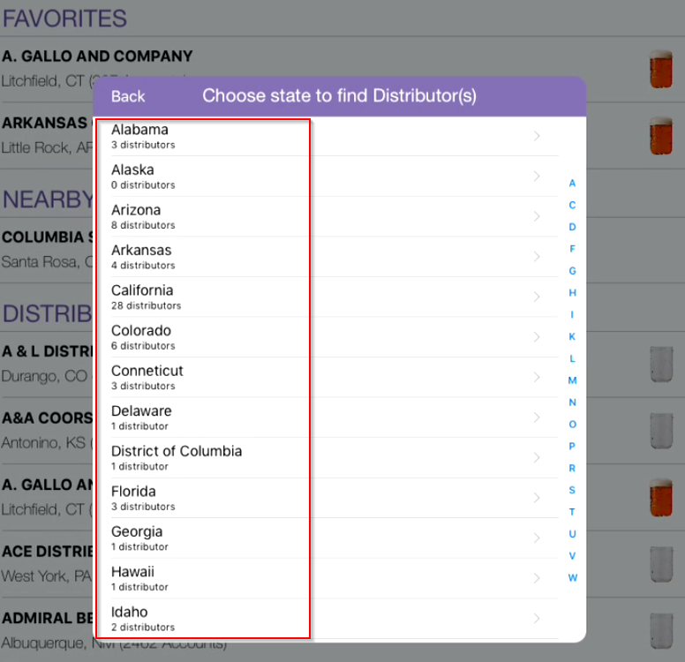

Choose the desired state, and off you go! You’ll now see a list of all distributors serving that state.

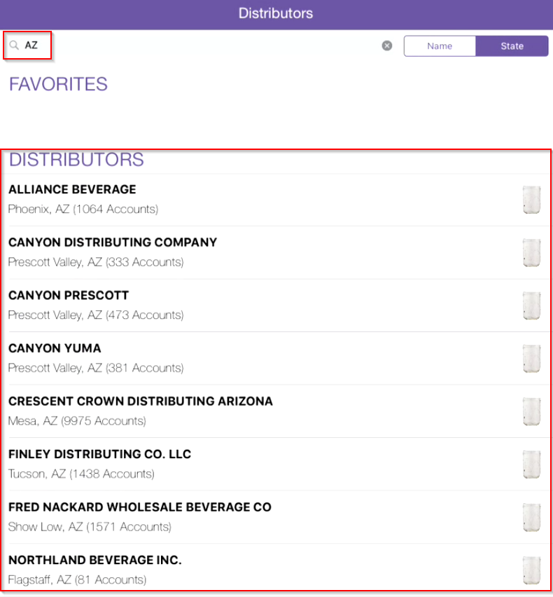

**NOTE:** It’s not possible to search by distributor names

in the “by State” distributor view, and Favorites will only appear if they belong within that state.

### Favorites

Favorited distributors are distributors you’d like to easily access every time you log in to the app, and the Favorites section is where these favorited distributors are displayed.

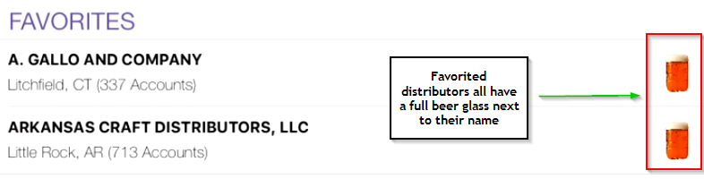

As mentioned in the screenshot, all favorited distributors are shown with a full mason jar next to their name (mmm…tasty).

#### How to Favorite a Distributor

To “favorite” a distributor, either search or scroll for that distributor in the Distributors list, and press the empty mason jar next to the desired distributor:

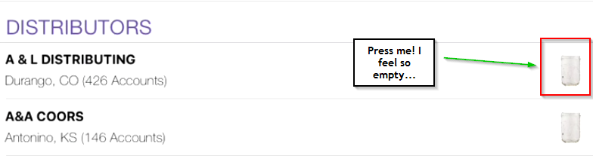

Once pressed, the empty jar will be replaced with a full glass of goodness, and the distributor will now be included in your list of Favorites.

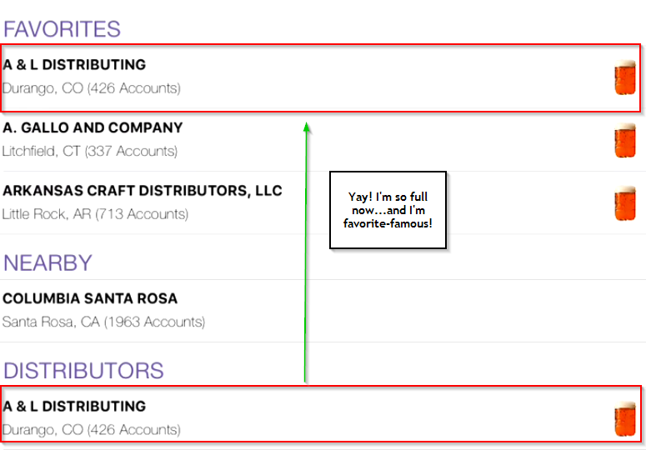

### Nearby

This section shows all the distributors that serve your nearby area (nearby is based on the GPS location of your iPad).

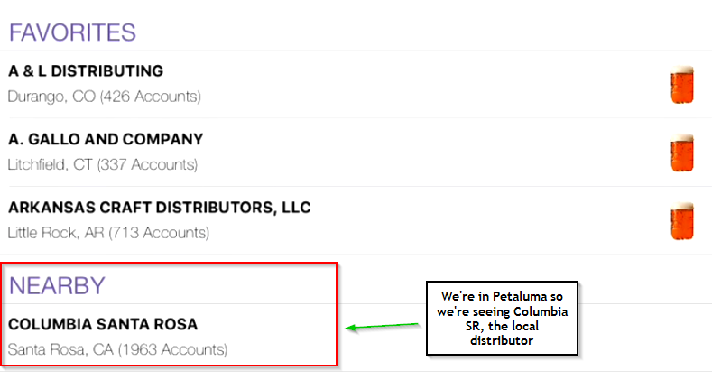

We’re in Petaluma, so we’re seeing Columbia Santa Rosa – whaddy’a expect?!

### Distributors

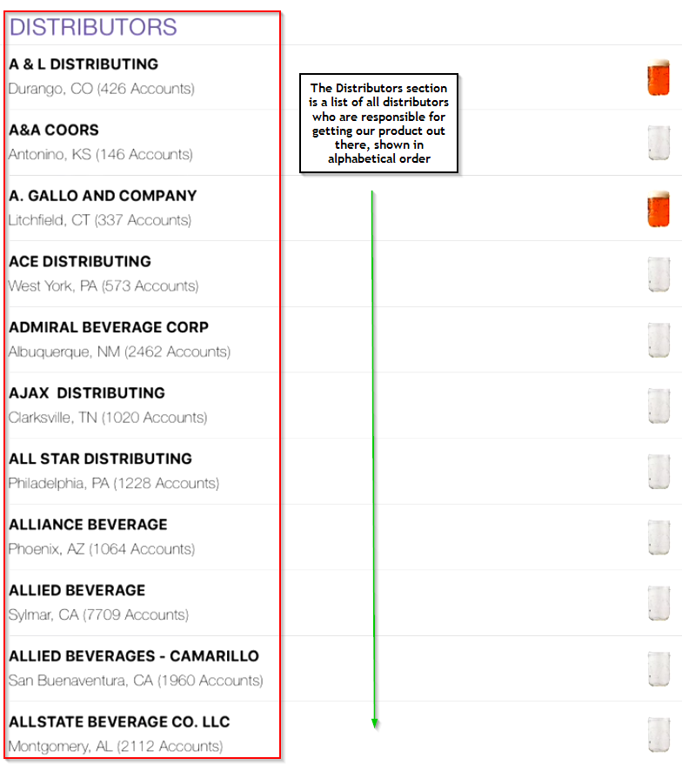

Here you can choose a distributor to “favorite” (see the Favorites section above); you can also select a distributor and see all the accounts for which that distributor is responsible (more on that in the next section).

## Distributor Account List

Distributors gonna distribute, and we gotta know where the beer is gonna go! This section goes into how we access the accounts for a specific distributor, and goes into more detail on how to filter and navigate this section of the app.

### Accessing the Account List

To access the list of accounts served by a particular distributor, press that distributor’s name on the Distributors page (you can access a distributor’s account list from any section on the Distributors page – Favorites, Nearby, or the Distributors list).

We’ll use Columbia Santa Rosa as an example (gotta root for the local boy, right?).

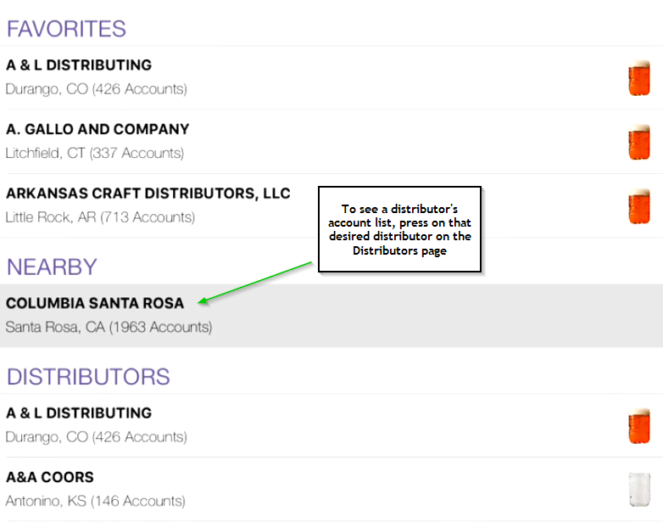

You’ll now be presented with the accounts for which this distributor is responsible.

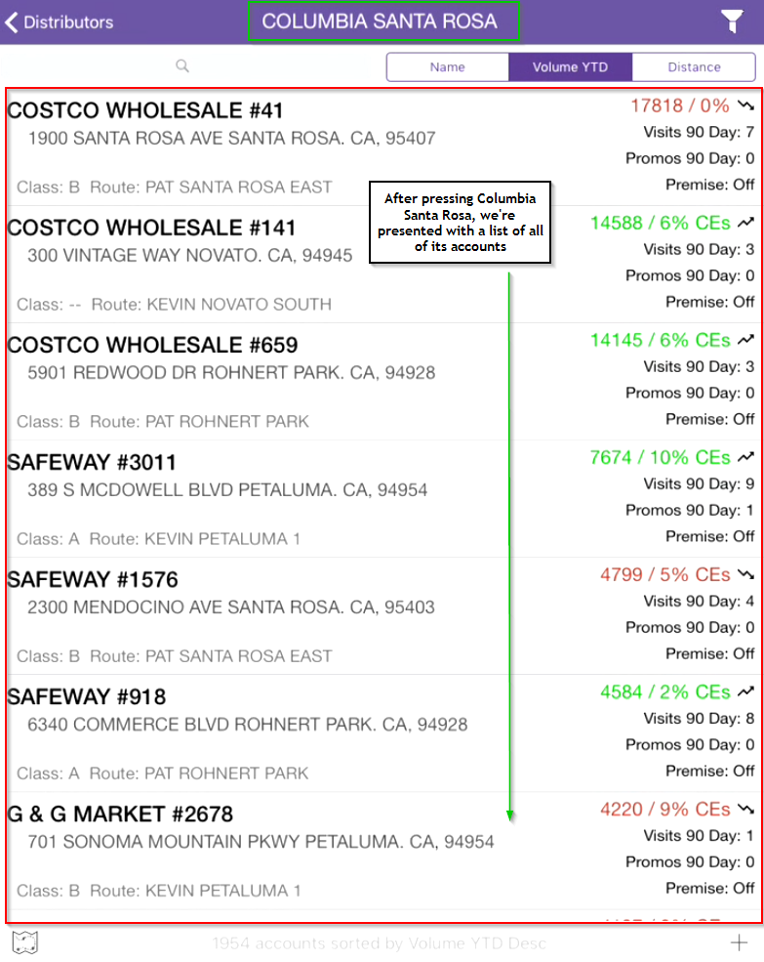

### Account List Overview

The Account List page is broken into 5 sections:

1. Advanced Filters
2. Search and Ordering
3. Account Information
4. Map View
5. Add Account

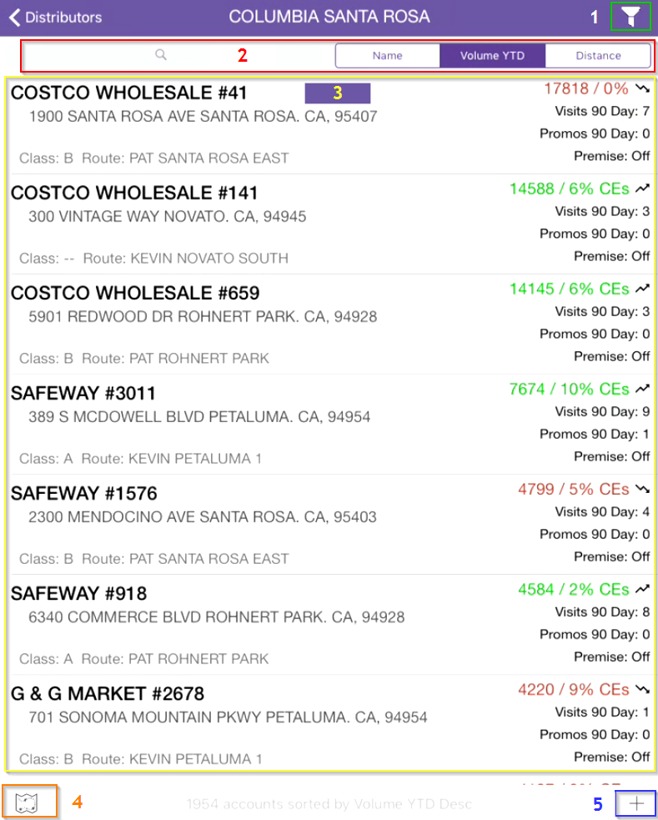

Let’s dig a bit deeper into each of these sections, shall we?

#### Advanced Filters

A new feature in CRM2 (this version of the CRM, in case you’re not sure), the Advanced Filters allow you to slice and dice the Account List so that you can cut out the noise and really focus on the accounts you want to see.

To access the Advanced Filters, press the filter icon in the top-right corner of the Accounts List page.

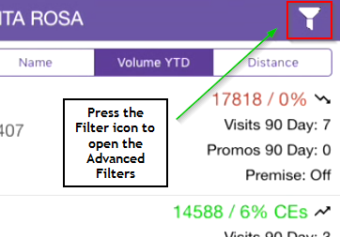

The Advanced Filters are comprised of 3 sections:

* Account Filter Categories: where we choose which the filter’s we’d like to set. Filters can be applied by **SKU**, **Brand**, **Pack Size**, **Route**, **Location**, and/or **Account Info**.
* Selected Filter Options: all chosen filter criteria are listed here; this area of the screen is always displayed and updates when the “Add to Filter” button is pressed (more on this in the example below).
* Filter Actions: a variety of actions we can perform on the filter set we’ve created.
  + *Clear* – removes all filters from the Selected Filter Options
  + *Search Now* – initiates the account search based on the filter criteria we’ve established
  + *Load* – load saved filter criteria sets
  + *Save* – save a set of filter criteria

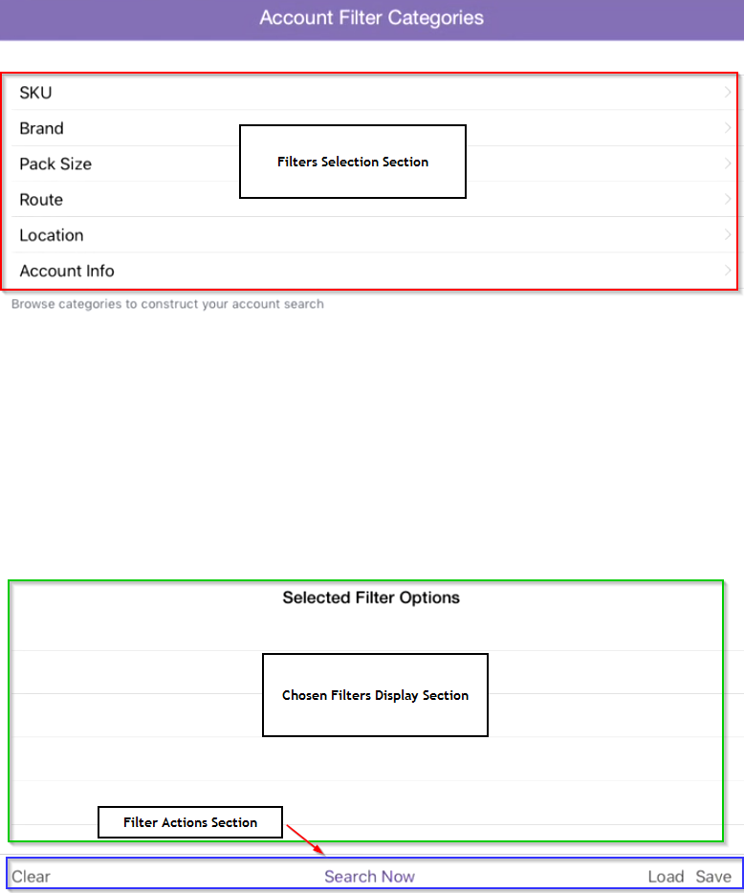

It might seem like a lot at first glance, but once you’ve walked through it a couple times it becomes more clear. How’s about an example?

##### Advanced Filters Example

Let’s say we want to filter the accounts we see in the Account List by SKU. First, select SKU from the Account Filter Categories.

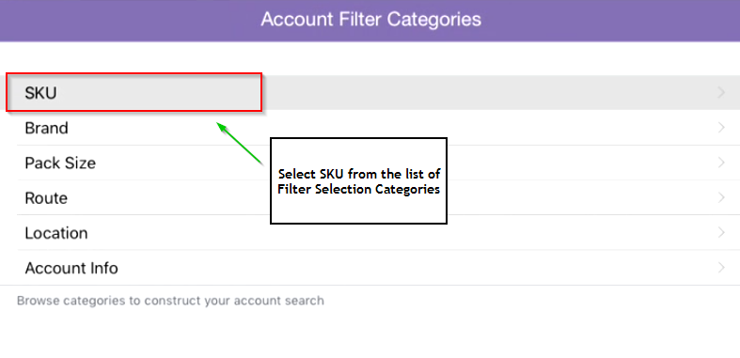

Once in the SKU Filter, we’re presented with a variety of filtering and selecting possibilities.

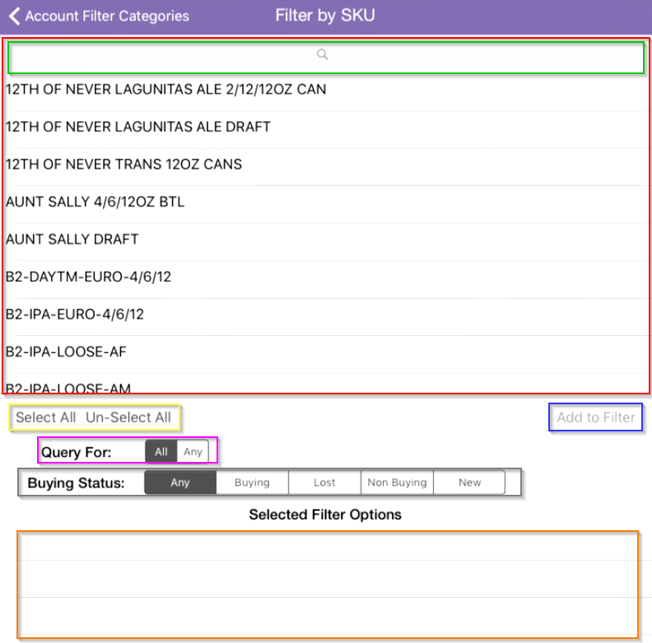

Here’s an outline of the function behind each of the items on the page:

* Item Selection List: in this case, we see a list of all possible SKUs
* Item Search Bar: Allows you to search for specific items in the Item Selection List
* Select All Un-Select All: Choose all items in the Item Selection List, or remove all currently selected items
* Query For: A delimiter which affects how the search is performed
  + If **All** is selected, then an account will appear in the Account List *only if all* of the items chosen in the Item Selection List exist for that account (think of this like “and”, as in “this and this and this and this”)
  + If **Any** is selected, then an account will appear in the Account List if any of the items chosen in the Item Selection List exist for that account (think of this like “either/or”, as in “either this or this or this or this”)
* Buying Status: This means what the status of the filter item is at the account
  + *Any*: Accounts with filter items that have any of the subsequent statuses are displayed
    - Think SKUs with any of the subsequent statuses
  + *Buying*: Accounts having a status of Buying for the chosen filter items will be displayed
    - Think SKUs the account is currently buying
  + *Lost*: Accounts having a status of Lost for the chosen filter items will be displayed
    - Think SKUs the account was buying but are no longer (after 30 days, 30 days or less of not buying)
  + *Non Buying*: Accounts having a status of Non Buying for the chosen filter items will be displayed
    - Think SKUs the account was buying but are no longer (greater than 60 days not buying)
  + *New*: Accounts having a status of New for the chosen filter items will be displayed
    - Think SKUs that have been recently purchased by the account (30 days or less)
* Add to Filter: After selecting the filter items and the desired Query For and Buying Status options, press Add to Filter to add these filter criteria to the Selected Filter Options list
* Selected Filter Options: This is the same section as described above in Advanced Filters

Let’s continue with our SKU example. If we want to filter for accounts that are newly carrying both IPA Draft and Little Sumpin’ Draft, we would setup the filters as follows:

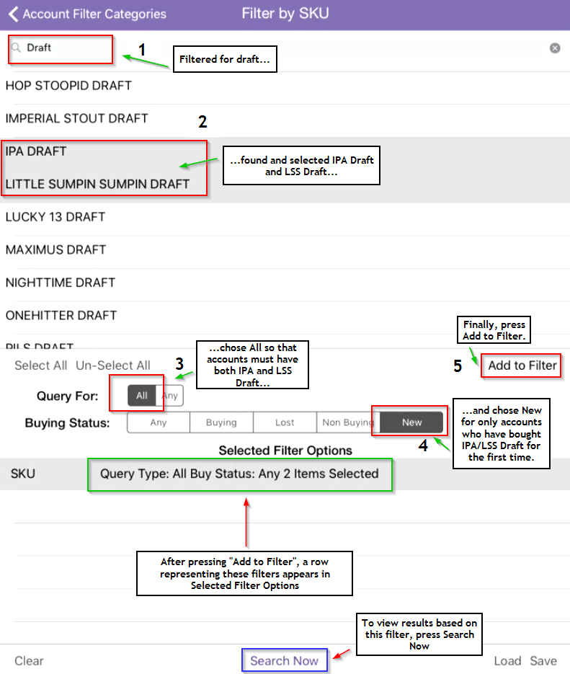

Let’s go through the steps on the screenshot one-by-one:

1. Type Draft in the search bar to find all Draft SKUs.
2. Select IPA DRAFT and LITTLE SUMPIN SUMPIN DRAFT from the result shown in the filter items list.
3. Set Query For to **All –** to be displayed in the Accounts List, accounts must carry both IPA and LSS Draft.
4. Set Buying Status to **New** – to be displayed in the Accounts List, IPA and LSS Draft must be new SKUs for the account.
5. Press “Add to Filter” – this adds the SKU filters we’ve established (filter items, Query For, and Buying Status) to the Selected Filter Options list.

If you can’t remember what filters were setup, press that row on the Selected Filter Options list to get an overview of that filter set.

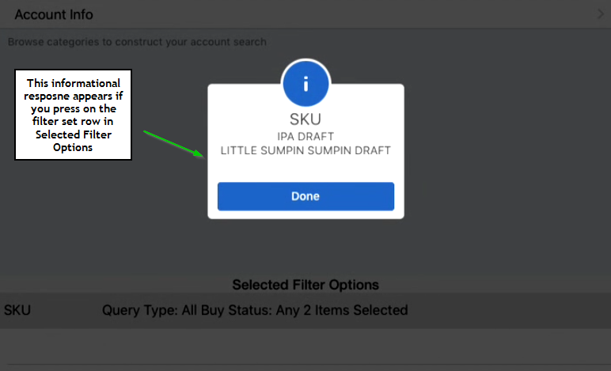

Now, to see the results in the Accounts List, press “Search Now”.

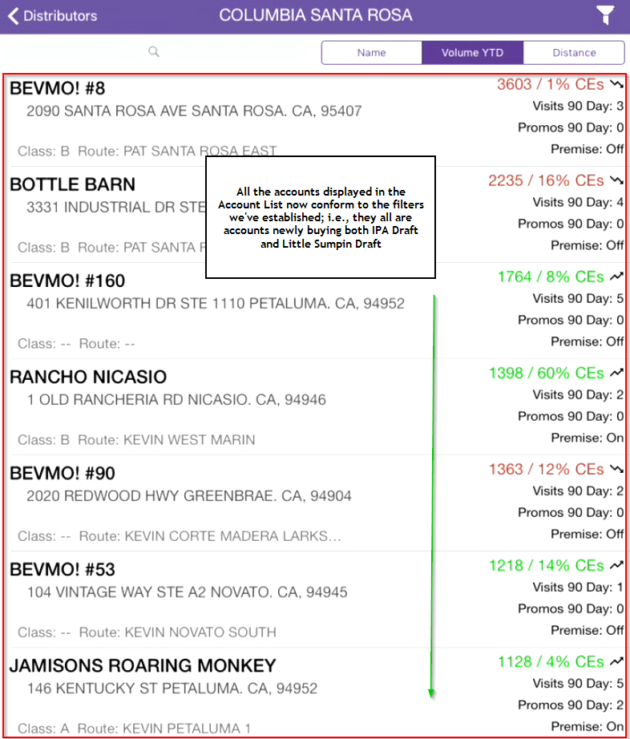

You can have up to 6 filter sets active at once, one for each Filter Category.

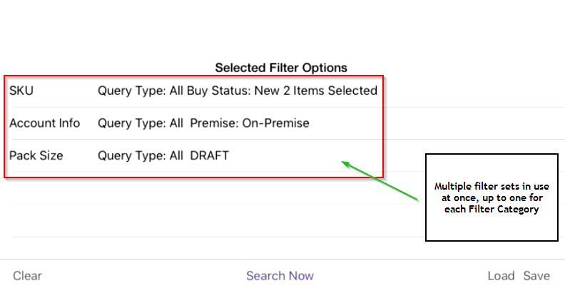

##### Removing Filters

To remove a filter from the Selected Filter Options list, swipe left on the desired filter. This will cause a red “Remove” button to appear.

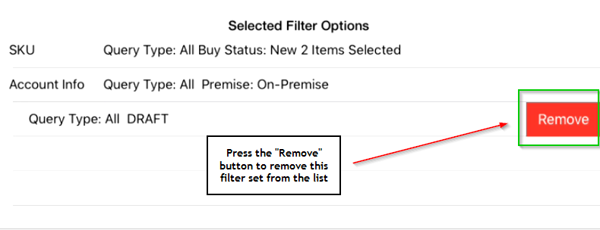

Once pressed, the filter set will be removed from the Selected Filter Options.

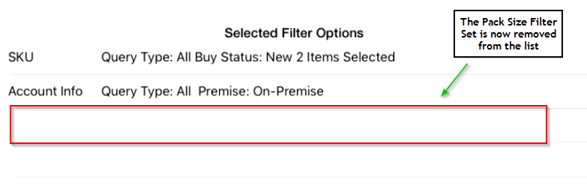

##### Save Filters

To save a set of filters, press the Save button in the bottom-right corner of the page.

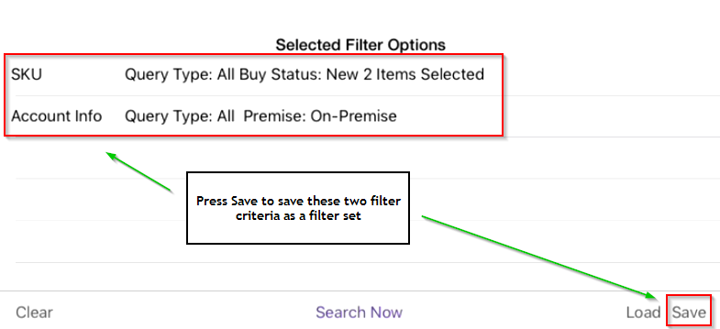

Once pressed, a window will appear asking you to give name the saved filter set.

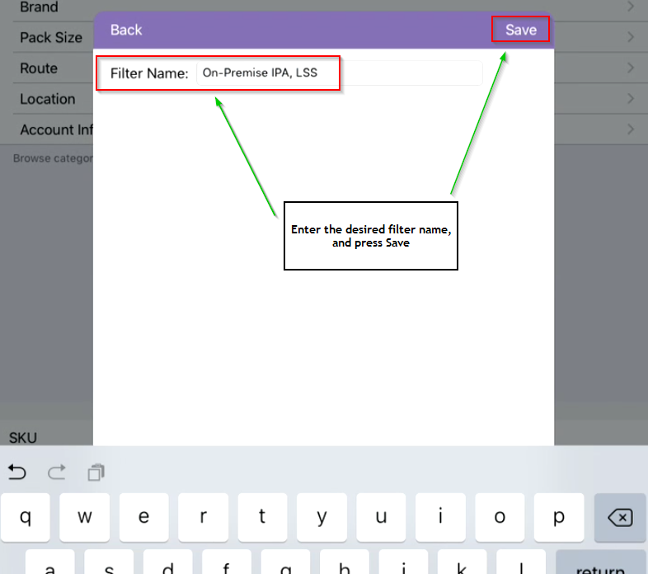

After saving, this filter set will be available for use any time.

##### Load Filters

To load a saved filter set, press the Load button, located to the left of the Save button in the bottom-right of the page.

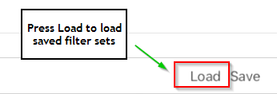

Once pressed, a window will appear with a list of all saved filter sets.

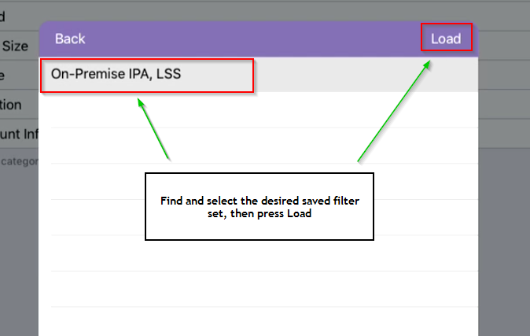

Find and select the set one you’re looking for. Once loaded, the filter set will appear in the Selected Filter Options list.

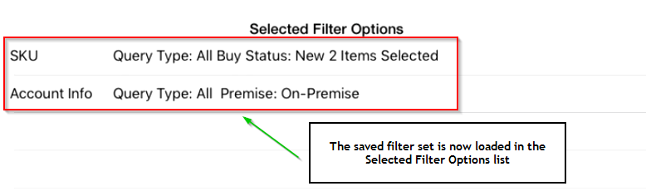

##### Filter Form Types

The Filters shown in the SKU example above are specific only to filtering for SKUs; the other filter categories have their own unique filter criteria that pertain to that type of account data.

Here’s a rundown of the other types of filter criteria views you’ll confront:

**Filter Item list with Query For Option**

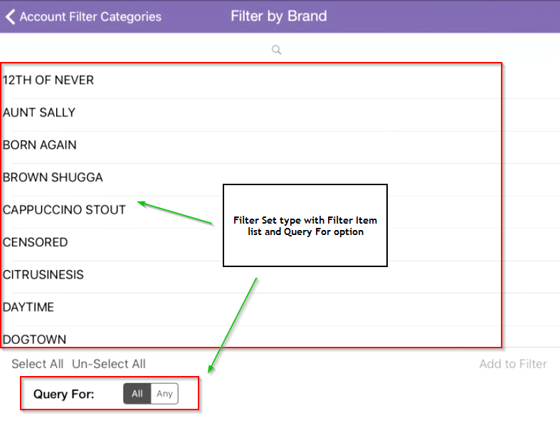

This filter criteria format applies to the following categories: **Brand**, **Pack Size**, **Route**, and **Location**, with location having free-text fields as opposed to a list of items in the filter items list.

**Account Info Filter Criteria**

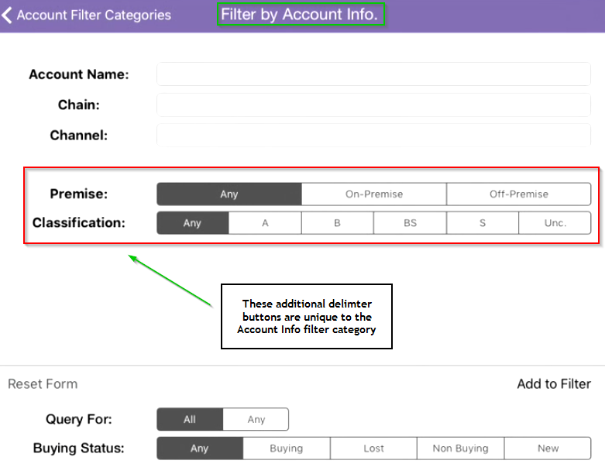

This filter criteria format applies only to the Account Info category, hence the name. In this format, we’re given a set of free-text fields to enter the specific account name or chain pertaining to the account, as well as an additional set of button delimiters:

* Premise
* Classification

#### Account List Search and Ordering

As on the Distributors page, the search bar is used to refine the account list displayed. Accounts will be filtered down as text is entered, until the desired account is displayed.

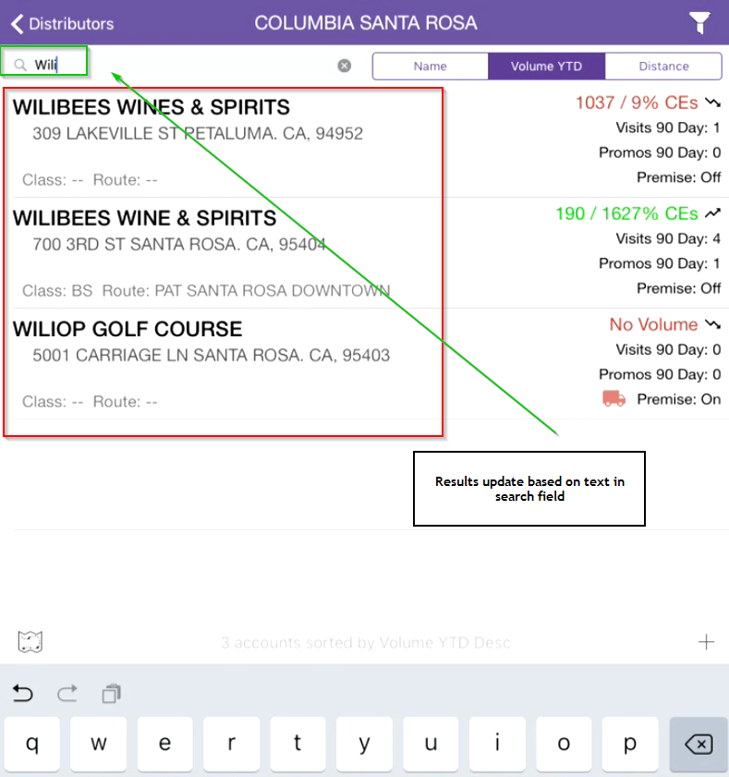

##### Name

The Name button sorts the account list by Name. Pressing the Name button shows the list of accounts in alphabetical order,

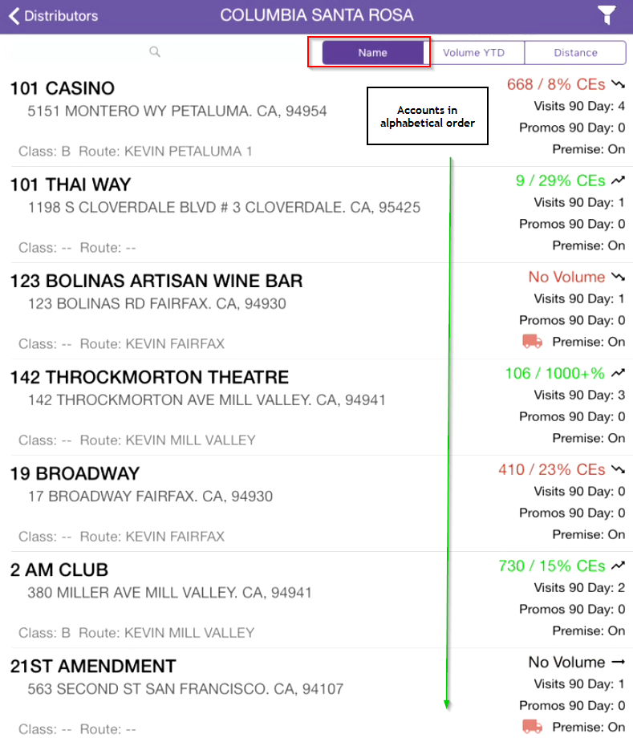

and pressing the button a second time shows the accounts in reverse-alphabetical order (the Internet says this is zalphabetical order, but I’m getting a red squiggly…).

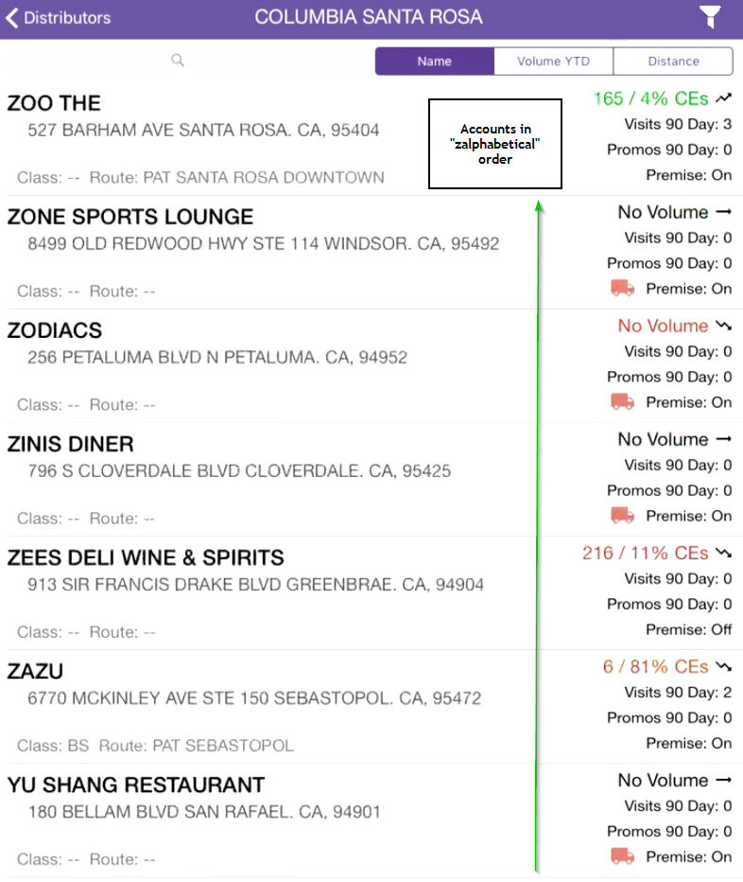

##### Volume YTD

This is the default sorting order when accessing the Account List. Accounts are sorted by highest-to-lowest Volume YTD,

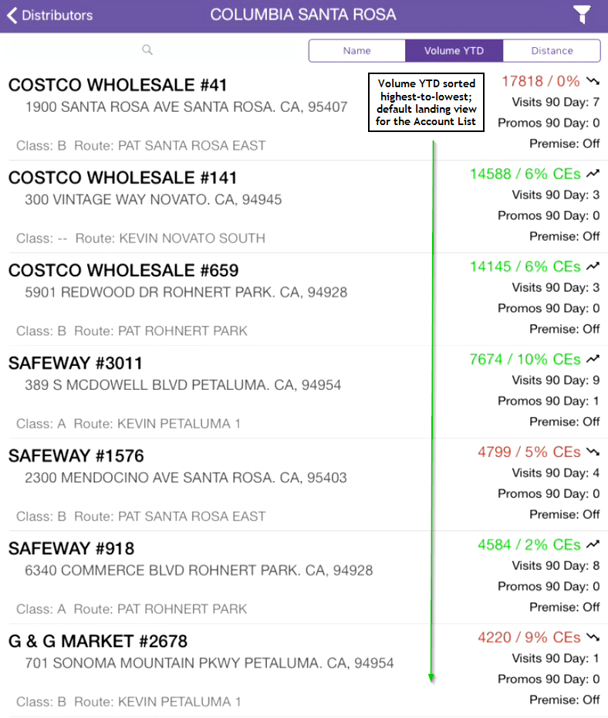

and pressing the Volume YTD button will sort the accounts by lowest-to-highest Volume YTD.

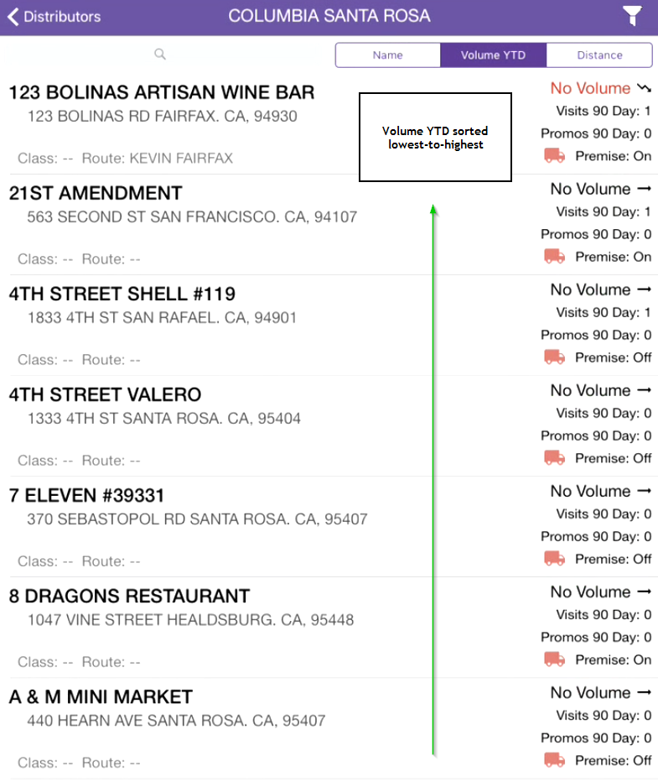

*No volume? Bolinas ain’t what it used to be…*

##### Distance

This sorts accounts based on geographical distance away from the GPS location of the iPad at the time of sort. On first press, accounts are ordered closest-to-farthest,

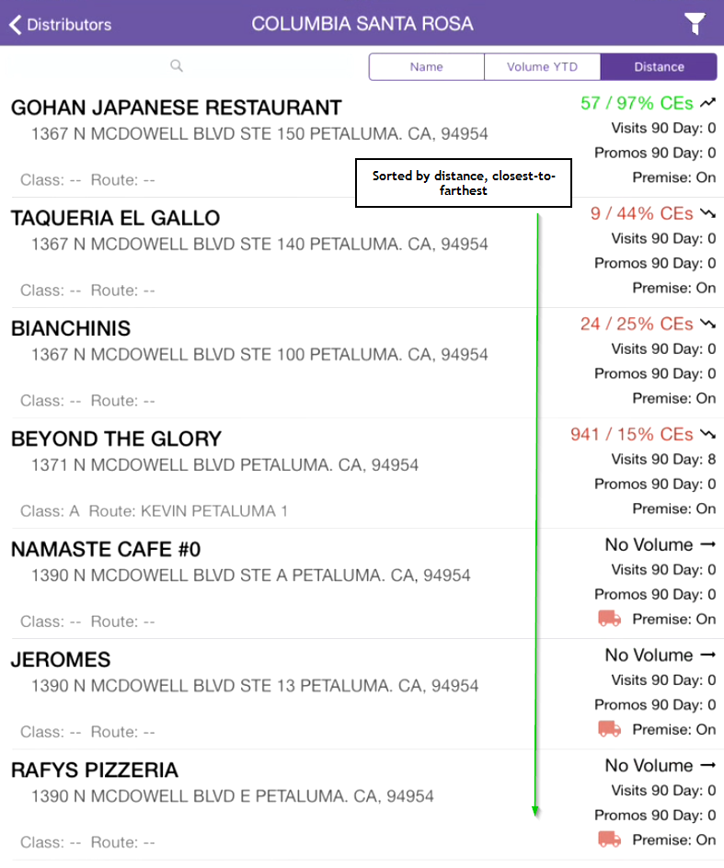

And pressing the Distance button a second time will sort accounts farthest-to-closest.

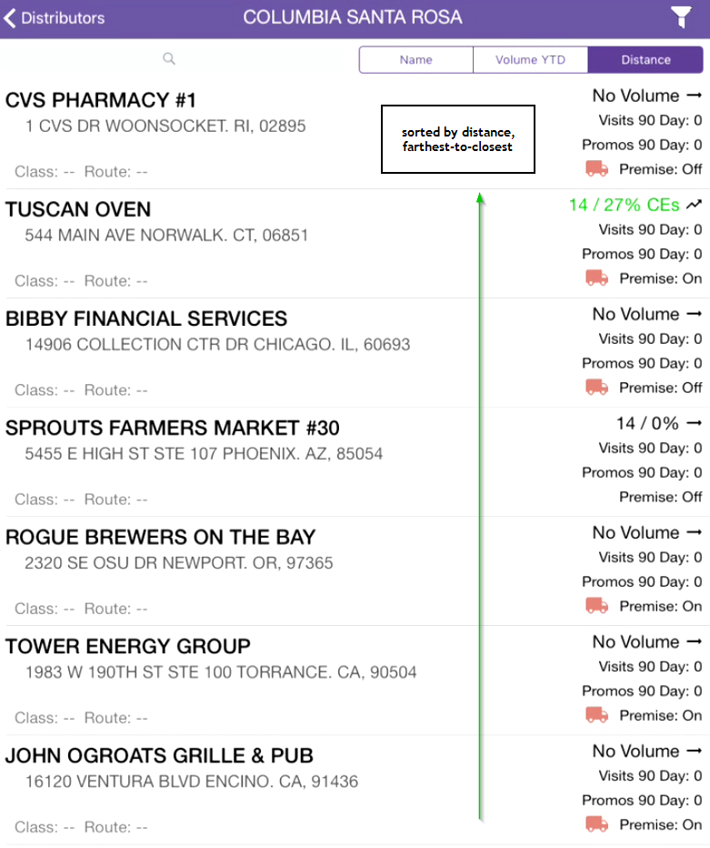

#### Account Information

Each account is represented as an item in the overall Account List.

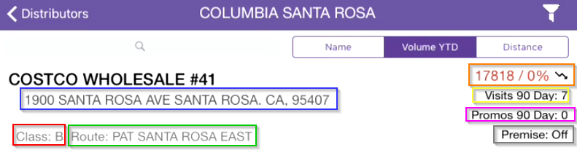

The following information is displayed along with the account name:

* Address
* Class (Master Route Class)
* Route
* Total Volume YTD in CEs
* % Vol Over LY
* Total visits in the past 90 days
* Total promos in the past 90 days
* Premise type (On or Off)

Selecting an account from the Account List will bring you to the Account Overview for that account, where you’ll find Account Visits, Contact Info, and whole bunch of other goodies (more on this in the Account Overview section).

#### Map View

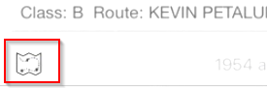

Pressing the map icon in the bottom-left corner of the Account List page will bring up a map with all of the listed accounts shown as dropped pins.

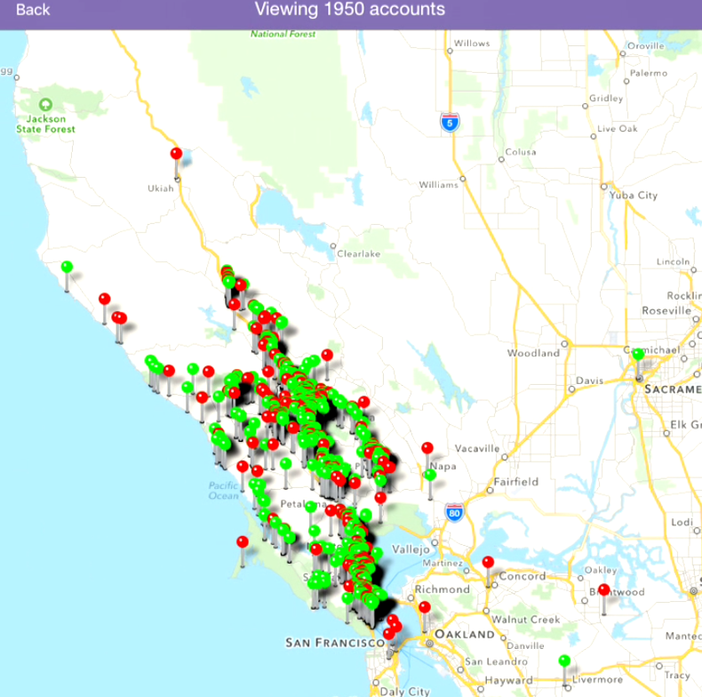

**NOTE:** the accounts shown on the map will differ depending on the Advanced Filters being applied.

Accounts designated with a red pin are non-buying accounts, and accounts designated with a green pin are buying accounts.

#### Add Account

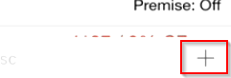

The “Add Account” feature is used for creating “faked” accounts – that is, placeholders for accounts that have yet to buy our beer. To create an account, press the + button on the bottom-left of the Accounts List page. The New Account page will appear.

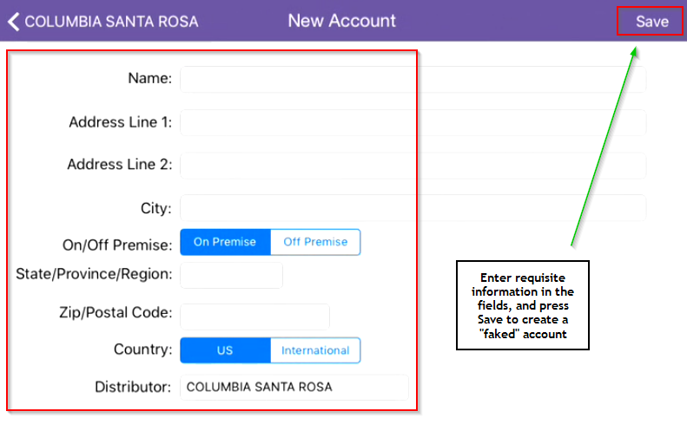

Enter the necessary information in all required fields (all fields except Address Line 2 are required) and press Save.

**NOTE:** After creating a “faked” account, you can add all the same information as you would against a regular account: account visits, action items, contact info, etc.

Once the placement goes through and the real account information is received, the “faked” and real accounts will merge into a single Active account (in case the merge doesn’t happen, let us know and we’ll do it manually!)

## Account Overview

Every account has an Account Overview page, which is where all previous visits are chronicled, new visits are added, distribution information is displayed, contact information is recorded – it’s basically the epicenter of information for each account, and probably where you’ll be spending *a lot* of time. So, take a load off and listen for a while.

### Accessing the Account Overview

To access the Account Overview for an account, find and select the account in the Account List of the distributor responsible for that account. In this example, we’ll choose the Costco in RohPo (that’s an abbreviation of Rohnert Park for all you readers outside the north bay).

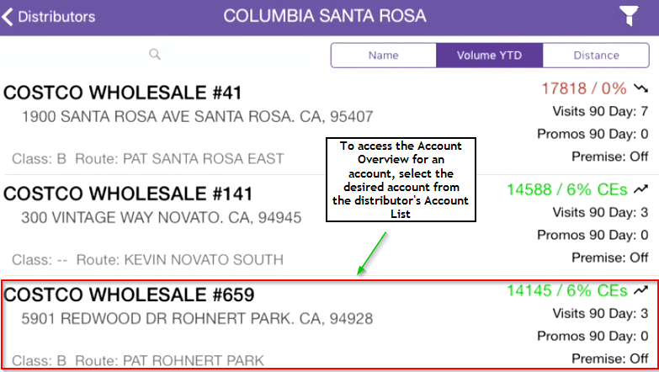

**NOTE:** Account Overviews cannot be reached independently of a distributor – users must first select a distributor, then select the desired account from the Account List.

After selecting the account, the Account Overview page for that account will appear.

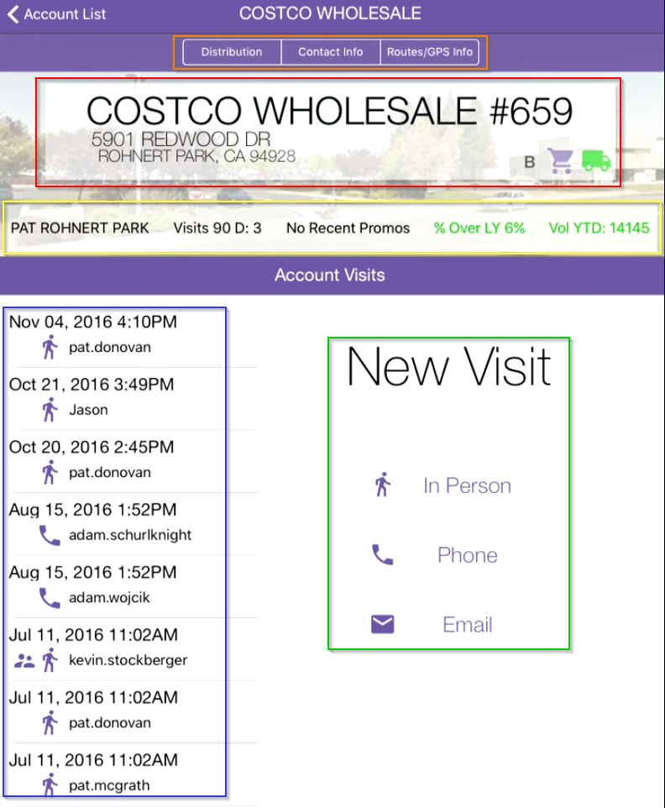

The Account Overview consists of the following sections:

* Account Details
* General Account Information
* Account Performance
* Past Visits
* New Visits

I think it’s…wait, sorry, wrong color. I think it’s high-time we put each one of these sections under the microscope.

#### Account Details

The Account Details section contains three subsections, each of which has its own special little sumpin’.

##### Distribution

Clicking the Distribution tab will bring up a buying/non-buying history of the account. The Buying section displays all SKUs the account has brought in over the following time periods:

* the past 90 days for bottles/cans; and
* the past 60 days for draft.

Details regarding Volume YTD, % Over LY, and the Last Purchase Date for each SKU are also shown.

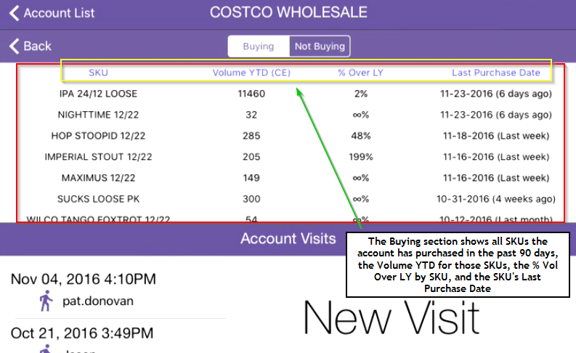

Navigate to the Not Buying section, and you’ll see all SKUs that were bought this or last year, but are currently not buying.

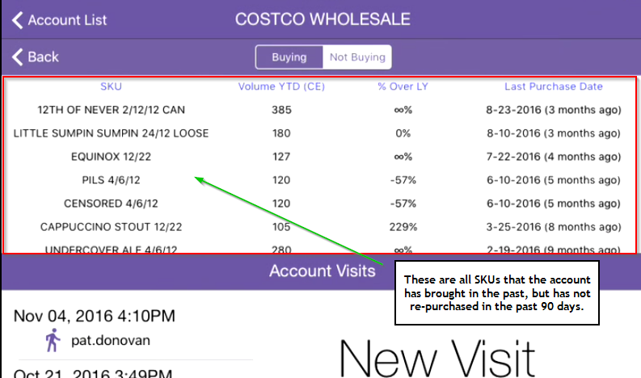

You’ll see the same SKU-related information (Volume YTD, % Over LY, Last Purchase Date) for each SKU in the Not Buying section as you saw in the Buying section.

##### Contact Info

To access the account contact information, press the Contact Info button. Once pressed, a new view will appear with tabs for Owner, Buyer, and Other. Users can either view existing contact information within these categories, or add new contacts by selecting the desired contact type and then entering in the requisite information for that account.

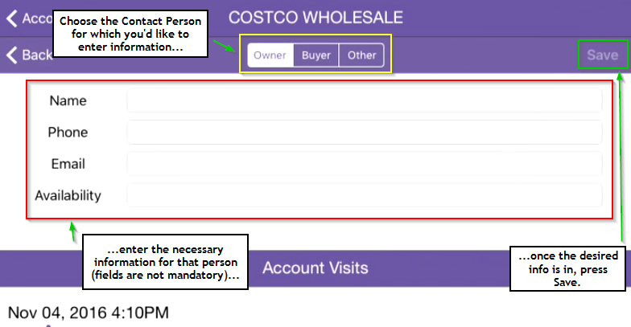

##### Route/GPS Info

The Route/GPS Info tab is currently on vacation, but will be back in the office again soon. If the matter is urgent, please see the Account List Map View.

#### General Account Information

This section provides the user with the at-a-glance essentials of the account: the account name, address, master route class, whether it’s buying or non-buying, and the Premise type.

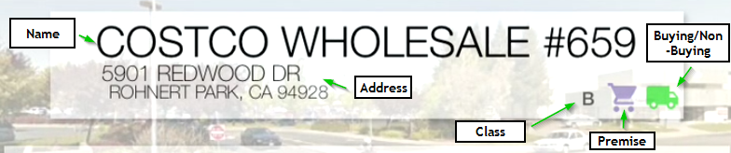

**Premise** can show either as a shopping cart (On-Premise) or a beer mug (Off-Premise). A green delivery truck indicates that an account is **Buying**, while a red delivery truck indicates that an account is **Non-Buying**.

#### Account Performance

The Account Performance section provides the user with a dashboard overview of the account’s health via Vol YTD and % Over LY, both in terms of CEs. Attention being paid to that account is also monitored with the route name and rolling 90 day visits/promos totals.

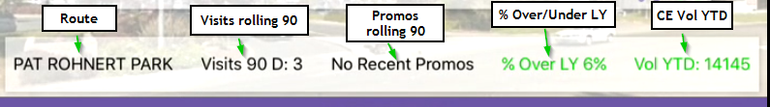

#### Past Visits

This section provides a log of all past visits to the account in question, along with the following information:

* Date/timestamp of the visit
* Lagunator who made the visit
* Visit type:

 In Person

 Phone

Email



Visits are ordered from most-to-least recent. Selecting any visit from the Past Visits section will open the saved information relating to that visit (more on this in the Accessing Past Visits section).

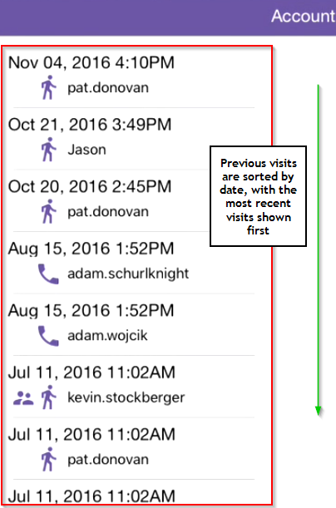

#### New Visits

This is where users enter new visits against this account; after a while, you’ll probably see a lot of fingerprints on this part of your screen.

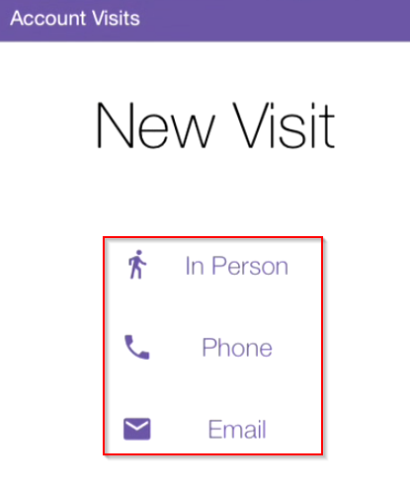

Users have the option of entering any one of the three possible visit types: In Person, Phone, or Email.

More on entering new visits will be covered in the Entering New Visits section.

## Account Visits

You’re out there hitting the streets, slinging cases, and visiting accounts. And we want to know about it! In all seriousness, logging visits is arguably the most important aspect of the app as it is the vehicle by which you’ll be granted beer placement and non-buying account credits. Some say the proof is in the pudding; we say the proof is in the visit.

### Entering New Visits

There are three types of visits that can be entered: **In Person**, **Phone** and **Email**.

While the Visit Overview and Entry page is the same for all three visit types, there are some peculiarities for each that you should be aware of:

**In Person**: This is visit type numero uno, and are actual visits to the account in question. *Only create an In Person visit if you actually do visit the account* as the GPS location of the account is compared against the GPS location of your iPad, and you’ll be red-flagged if the distance between the two is greater than half-a-mile.

**Phone/Email**: These two are largely equivalent in their value, with Phone visits given slightly more weight due to the fact that you’ve spoken with the Owner/Buyer/etc.

To enter a visit for an account, press the requisite visit type in the New Visit section on the Account Overview page – in this example, we’ll be doing an In Person visit.

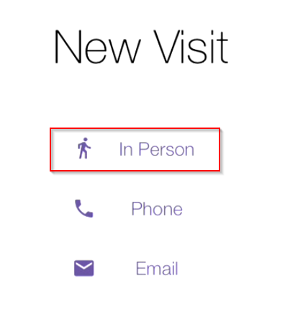

This will bring up the Visit Overview and Entry page. This page is broken up into four sections:

1. QA Survey
2. Pricing Survey
3. Sales Drivers
4. Action Items

Relax, we’ll go through each in detail.

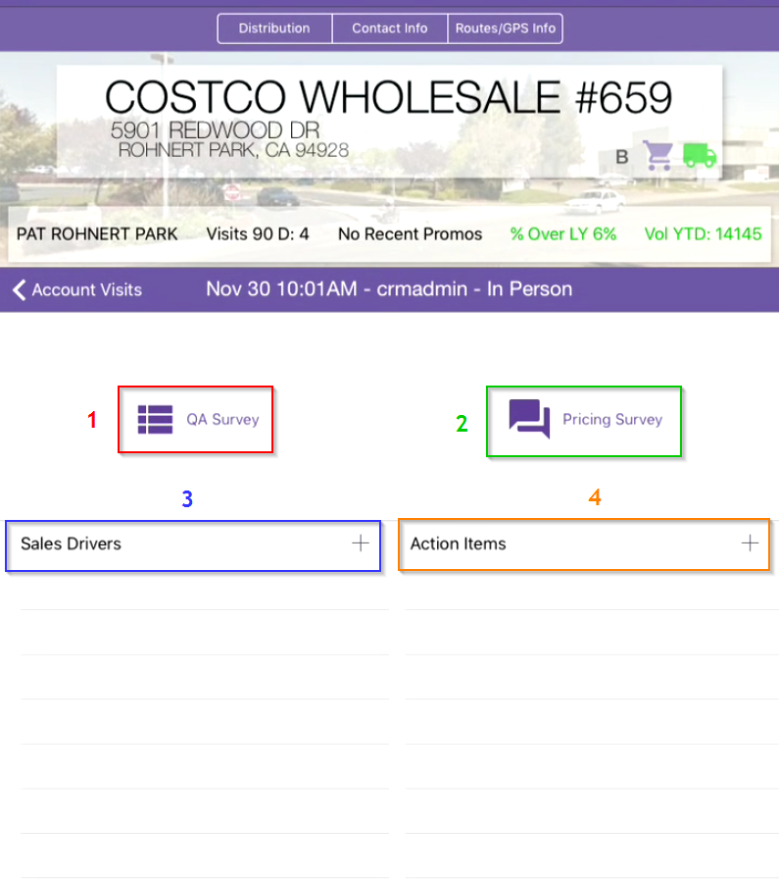

#### QA Survey

The QA Survey section is for entering SKU surveys when doing an In Person visit. Selecting QA Survey on the Visit Overview and Entry page will bring up the QA Survey entry screen.

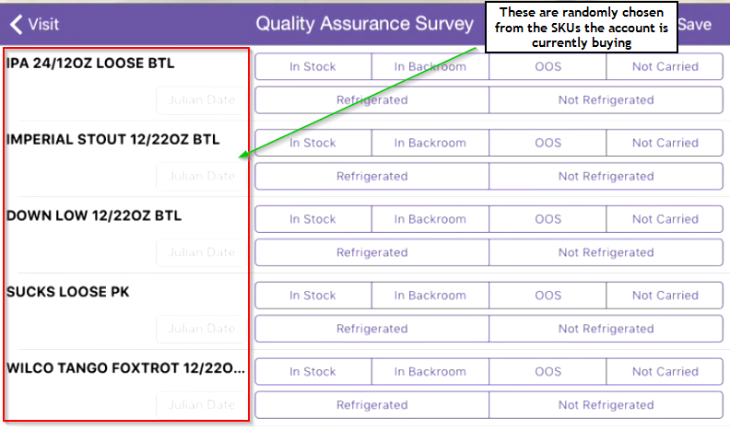

The SKUs shown on the QA Survey page are a random selection of SKUs that the account is currently buying – if you look at the Distribution tab in the Account Overview header, you’ll see all of these SKUs appearing in the Buying section. A maximum of 5 SKUs are selected for the QA survey; if the account is buying less than 5 SKUs, then only that number of SKUs will be shown.

When entering the survey, there are four possible QA statuses to choose from:

* In Stock
* In Backroom
* OOS (Out Of Stock)
* Not Carried

If you select either **In Stock** or **In Backroom,** you *must*select either **Refrigerated** or **Not Refrigerated** and enter the Julian Date specified on the bottle in the **Julian Date** field.

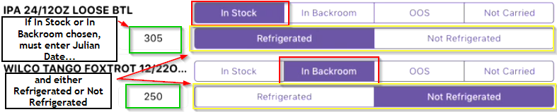

If you select either OOS or Not Carried, there’s no further information that needs to be recorded for that SKU (if the SKU ain’t there, you can’t tell if it’s refrigerated or not, now can you?).

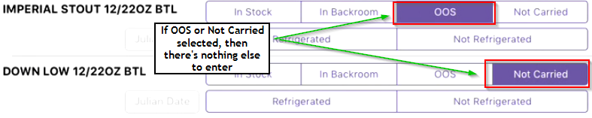

Before exiting the survey, be sure to press Save – the survey **will not save** if you do not press Save before navigating back to the Account Visit Overview.

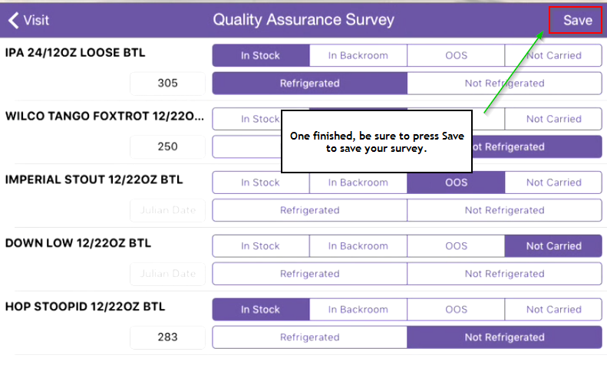

#### Pricing Survey

Due to unforeseen circumstances, Pricing Survey is not available at the moment. We wish it a speedy recovery and hope to have it back with us again soon.

#### Sales Drivers

Sales Drivers are an integral part of any account visit, as these signify the work you performed at the account and are the keystone for you getting proper credit for the SKUs you sold in.

##### Adding Sales Drivers

To add Sales Drivers, press the + button on the right side of the Sales Drivers heading.

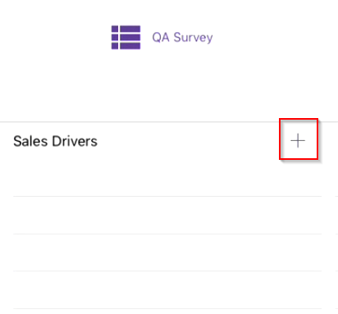

This will bring up the Sales Drivers entry page.

You are now presented with four Sales Drivers categories. Choose wisely:

* **Distribution**: a list of all possible SKUs that the account might take.
* **Off-Premise**: Various drivers relating to Off-Premise accounts (displays, POS, tasting/sampling events, etc.).
* **Price/Promotion**: Invites and other promotions.
* **Visibility**: Glassware, Neons, POS

**NOTE:** In this version of the CRM, only 4 Distribution Sales Drivers can be selected for any one visit; the previous version allowed for n number of Sales Drivers to be entered.

Important to know is that you can only enter Sales Drivers for one Category at a time. After entering Sales Drivers in one Category, press Save. After saving, all Categories will again be available for adding more Sales Drivers.

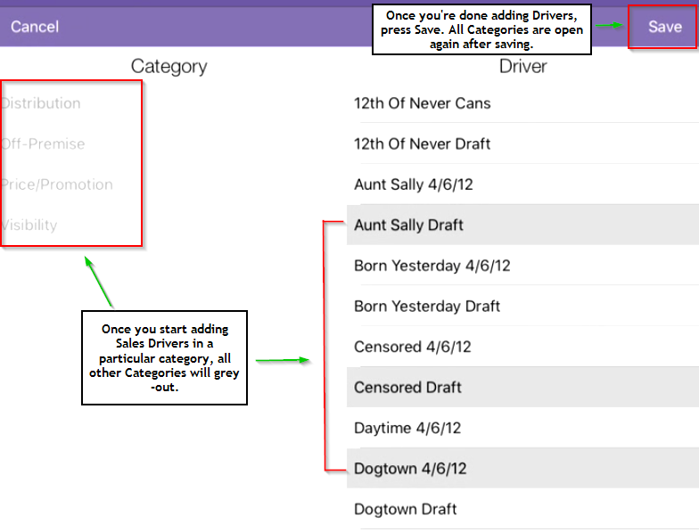

Once finished entering and saving all your desired Sales Drivers, navigate back the Account Visit by pressing the Visit button in the top-left corner of the Sales Drivers entry screen. All the Sales Drivers you just entered will now be shown in the Sales Drivers section on the Account Visit page.

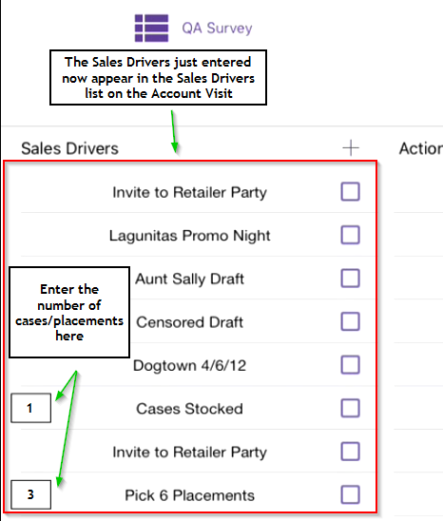

##### Special Off-Premise Sales Drivers

Some Off-Premise Sales Drivers require that you enter a number against them in the Sales Drivers list on the Account Visit before you can properly save and exit the visit (see the screenshot above? I’m talking about those black-framed boxes on the left-hand side). Just select the black box and enter in the number of cases stocked, pick 6 placements, etc., you need to for that Sales Driver.

Here is a list of all of these special Off-Premise Sales Drivers:

* Add Facings to Existing Placements
* Build Display
* Cases on Display
* Cases Stocked
* Pick 6 Placements

##### Completing Sales Drivers

To complete a Sales Driver, simply press the right-hand purple box on the Sales Driver you’d like to complete. Once the checkbox appears, you know the Sales Driver is completed.

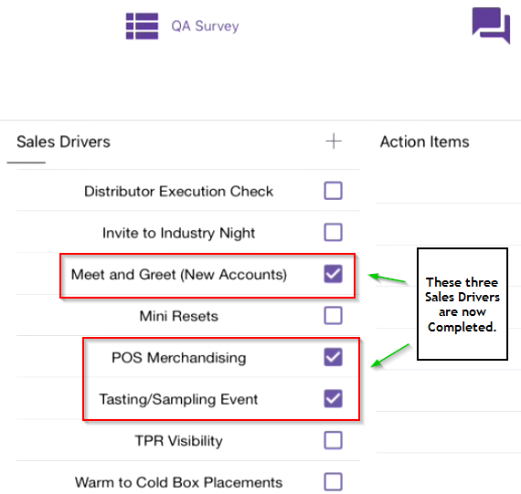

**NOTE:** In this version of the CRM, users cannot manually complete Distribution Sales Drivers – these will only be automatically completed; users can manually complete any other Category of Sales Driver.

#### Deleting Sales Drivers

If you’d like to remove a Sales Driver from the Account Visit, swipe left on that Sales Driver in the Sales Drivers list.

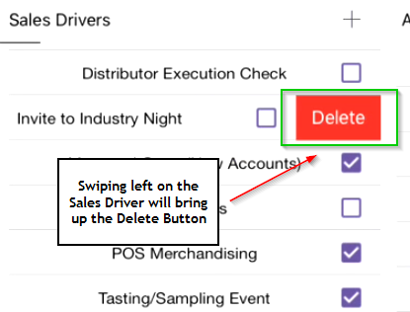

Once the Delete button is pressed, the Sales Driver will no longer appear on the Account Visit.

#### Action Items

Action Items are thoughts for yourself or notes you’d like to send along to the distributor regarding the account.

##### Adding Action Items

To add an Action Item, press the + button on the right side of the Action Items heading.

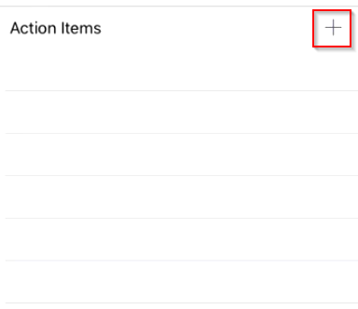

This will bring up the Action Items entry page.

To enter an Action Item, simply enter the title and description of the item (think subject and body of a letter), choose whether or not you want to Send this Action Item to the Distributor, and whether or not Follow-up is required. Once finished, press Save to save the Action Item and return to the Account Visit.

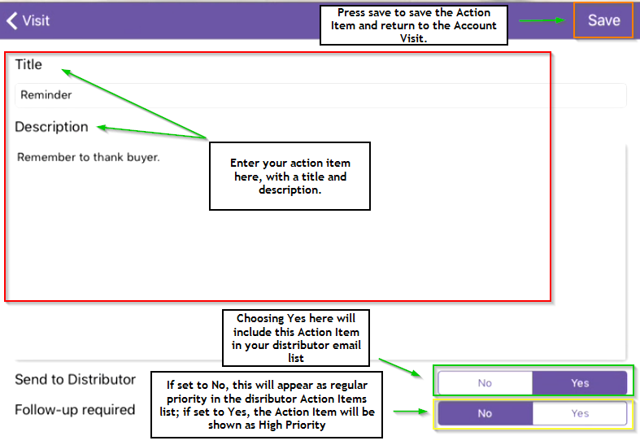

The “Send to Distributor” and “Follow-up required” buttons place a key in role in the life of the Action Item after it is saved:

* Send to Distributor
  + If *Yes* is selected, the Action Item will be included in the list of Action Items to send to the Distributor.
  + If *No* is selected, the Action Item will only be saved on the visit, and will not be available to send to the distributor.
* Follow-up required
  + If *Yes* is selected, the Action Item will be shown in a separate “High Priority” section at the top of the list of Action Items to send to the Distributor.
  + If *No* is selected, the Action Item will be included in the regular list of Action Items to send to the Distributor.

**NOTE:** The status of “Follow-up required” is used *only if* “Send to Distributor” is set to Yes; it is otherwise ignored.

After pressing save, you’ll be brought back to the Account Visit Overview and Entry page, where you’ll see the Action Item in the list of Action Items presented on the page.

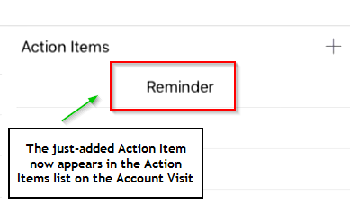

##### Deleting Action Items

To remove an Action Item, swipe left on the desired item in the Action Items list on the Account Visit Overview and Entry page. This will bring up a red Delete button on that Action Item.

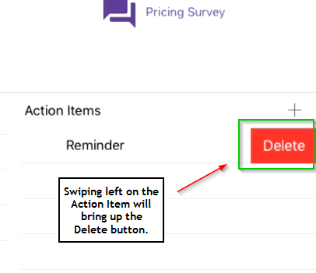

The Action Item will be removed after this Action Item is pressed.

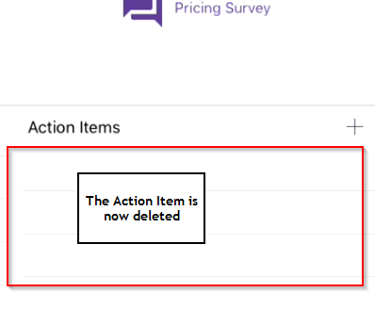

If the Action Item is deleted from the Account Visit, it will also be removed from the list of Action Items to send to the Distributor.

### Accessing Past Visits

Past visits are kept in a running list on the left-hand side of the Account Overview page (see Past Visits in the Account Overview section for more details).

To access a past visit, simply find and select the desired visit from the left-hand list.

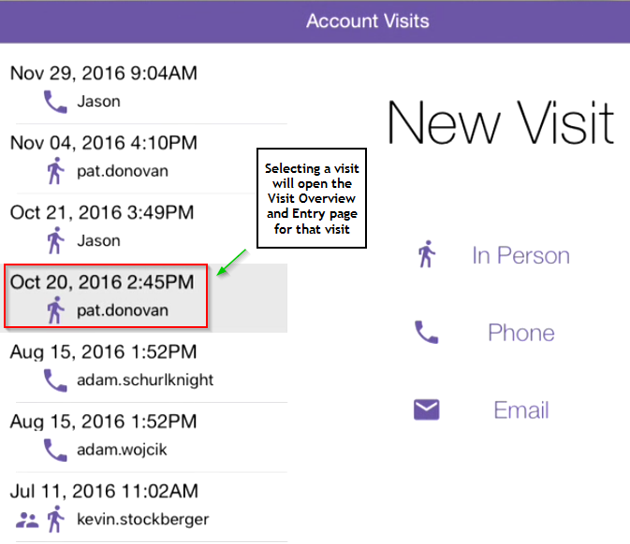

Once selected, the Account Visit Overview and Entry page for that visit will appear. It will be populated with all of the information the user entered when the visit was created.

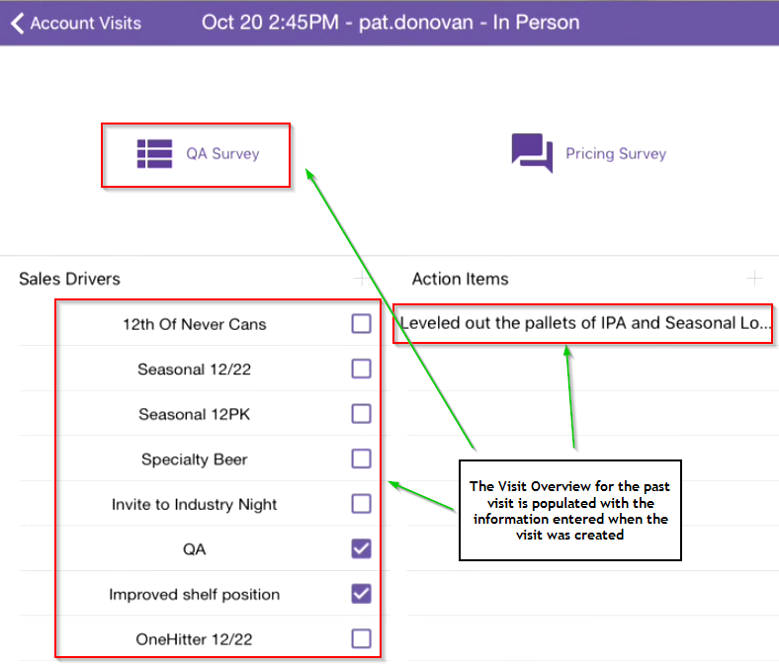

Changes can be made to past visits – for example, completing Sales Drivers or adding new Action Items. As there is no difference in the behavior between modifying a visit and adding a visit, see the Sales Drivers and Action Items sections in Entering New Visits for steps on how to perform these functions.

**NOTE:** It’s a good practice to go back and look over the Distribution Sales Drivers on your visits from the past 3 months (rolling), as these will show as completed once the distribution for that account comes in.

# My Stuff



You’ll find four sections on the My Stuff tab:

* Lagunator Scorecard
* Recent Visits
* Recent Placements
* High Five

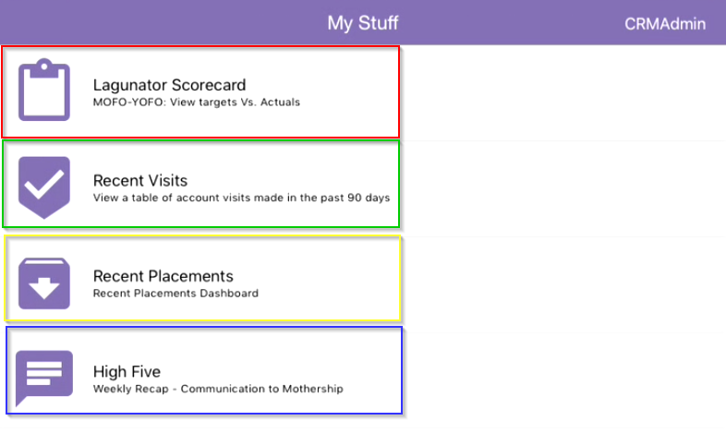

Maybe you want to see what each section is for? Me thinks so.

## Lagunator Scorecard

Consider the scorecard your barometer of success – it’s the central location to check your progress against the monthly and year-long targets you’ve been assigned.

After pressing the Lagunator Scorecard button, you’ll be presented with your Scorecard, split into two sections: **Distribution Targets** and **Execution Targets**.

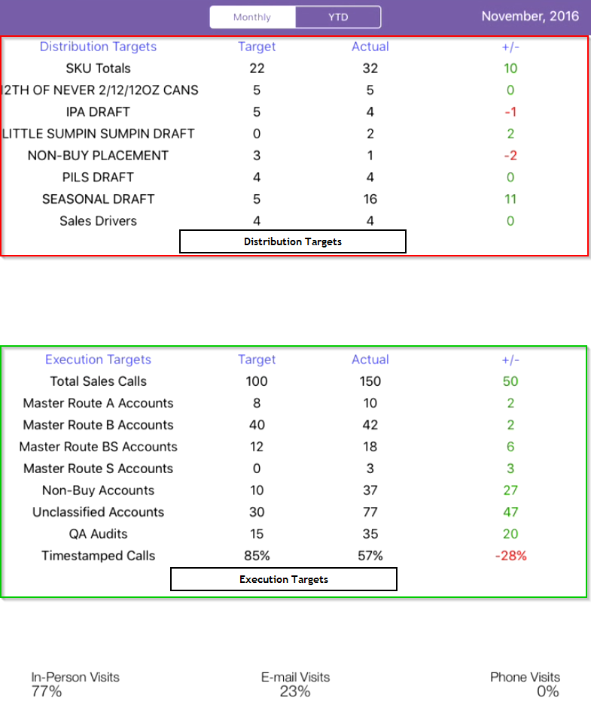

Distribution Targets are your beer placement goals, broken up by SKU; while Execution Targets are your sales call targets, broken up by Route.

### Changing Scorecard Timeframes

The landing page for the Scorecard is the Monthly view, which shows your progress against Targets for the current calendar month. Press YTD at the top of the page to switch to the Year-To-Date view; that is, an accumulated view of how you’ve done so far from the beginning of the year up until the present day.

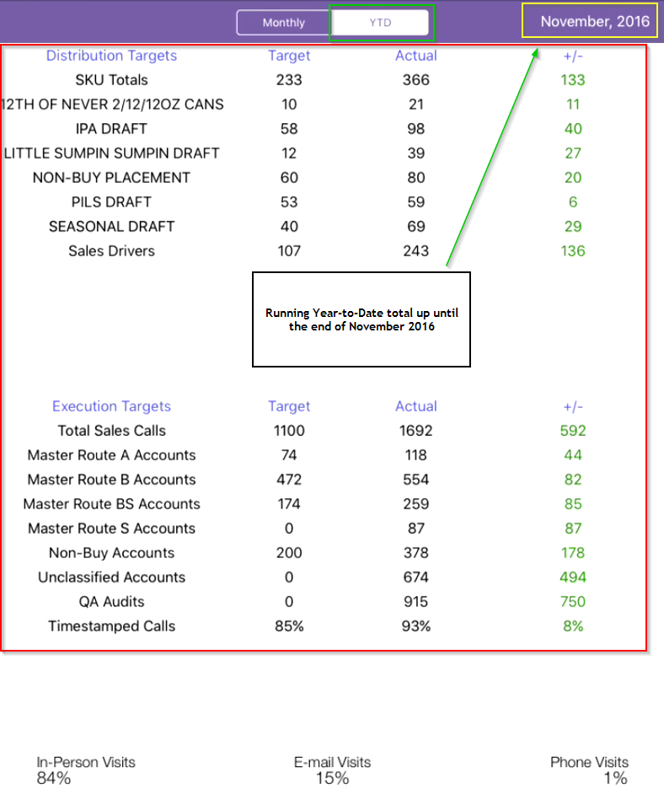

To change to a particular historical month, press the month shown at the top-right of the page (the default month will be the current month). You’ll be presented with a scrolling list and can navigate by month and year to the month of your choosing.

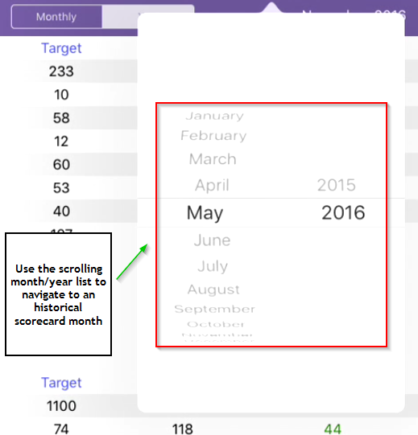

Once chosen, press out of the scroll list and both the Monthly and YTD views will update to that month’s historical snapshot.

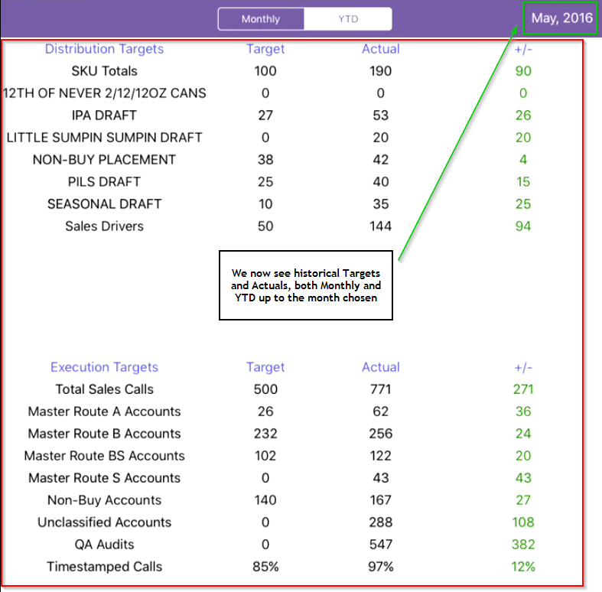

## Recent Visits

This section provides you with a quick-access list all your account visits over a rolling 90-day period.

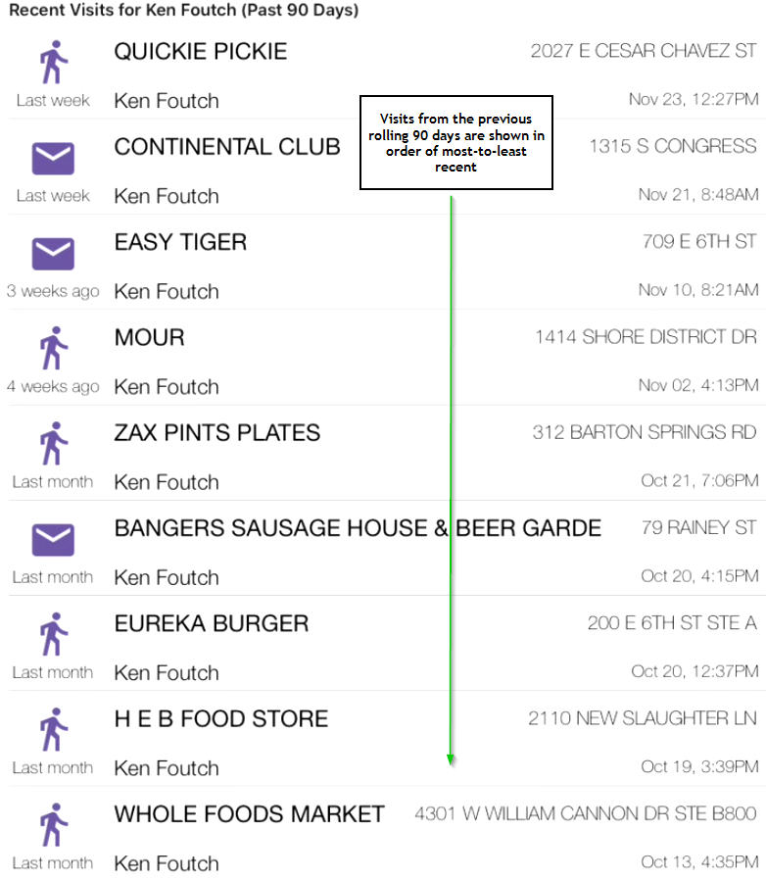

Selecting any visit from this list will direct you to the Visit Overview and Entry page for that visit (see Accessing Past Visits for more information on viewing and editing existing visits).

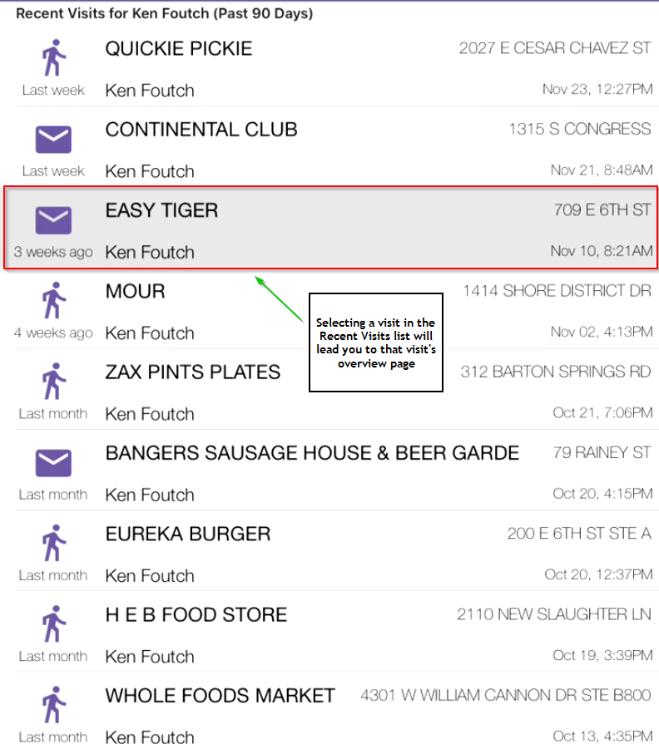

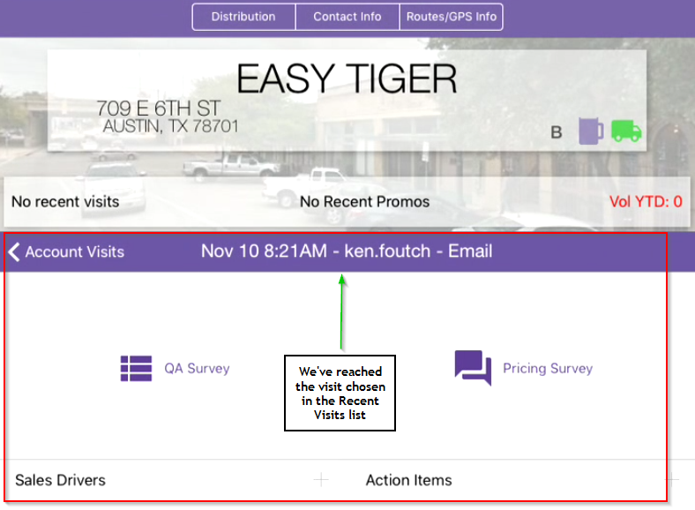

## Recent Placements

Recent Placements is one of those places you’ll want to go visit over and over again (kind of like Paris, or Milan, or…Petaluma?). This is where you can see all the placements you have been credited with over a rolling 90-day period; i.e., it’s where you’ll watch all your hard work pay off!

The presentation of the Recent Placements section is straightforward – when you enter Recent Placements, you’ll be presented with the placements list.

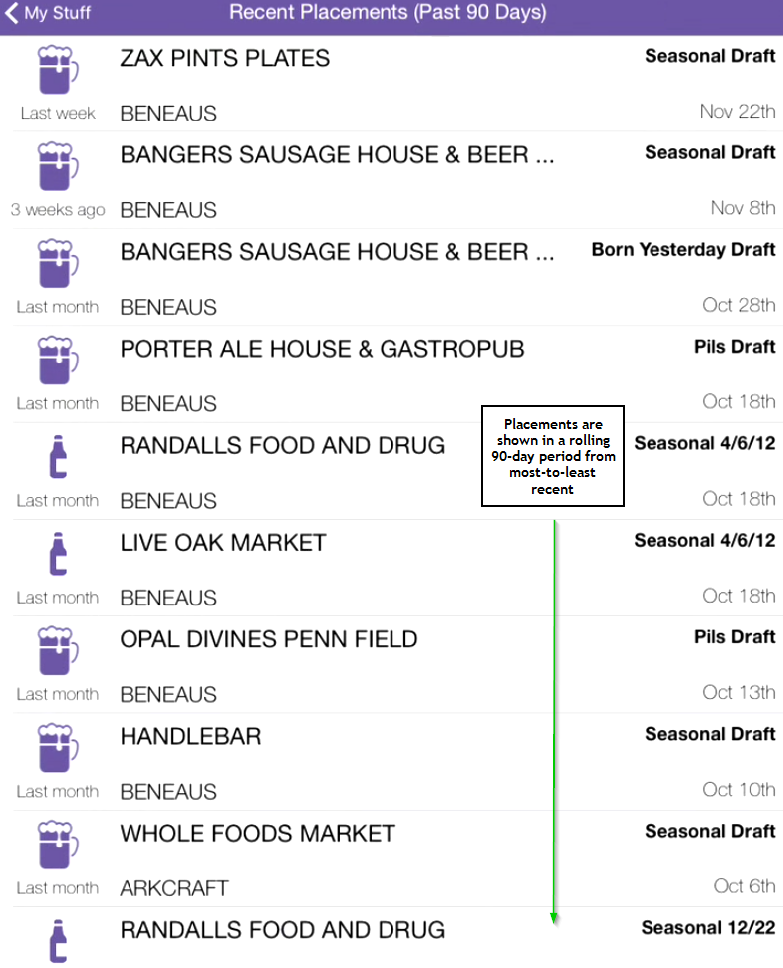

You can scroll through all the placements that have been credited to you over this period; each placement corresponds to a particular Distribution Sales Driver entered on a visit entered in the same rolling 90-day period.

## High Five

High Fives are where you enter in your weekly communiques and send them off to that special someone (your boss) so they know what you’re up to, how you’re doing out in the field, and any other thoughts or concerns you may have.

Entering the High Five section, you’ll be presented with a series of free-text fields, broken up into relevant sections.

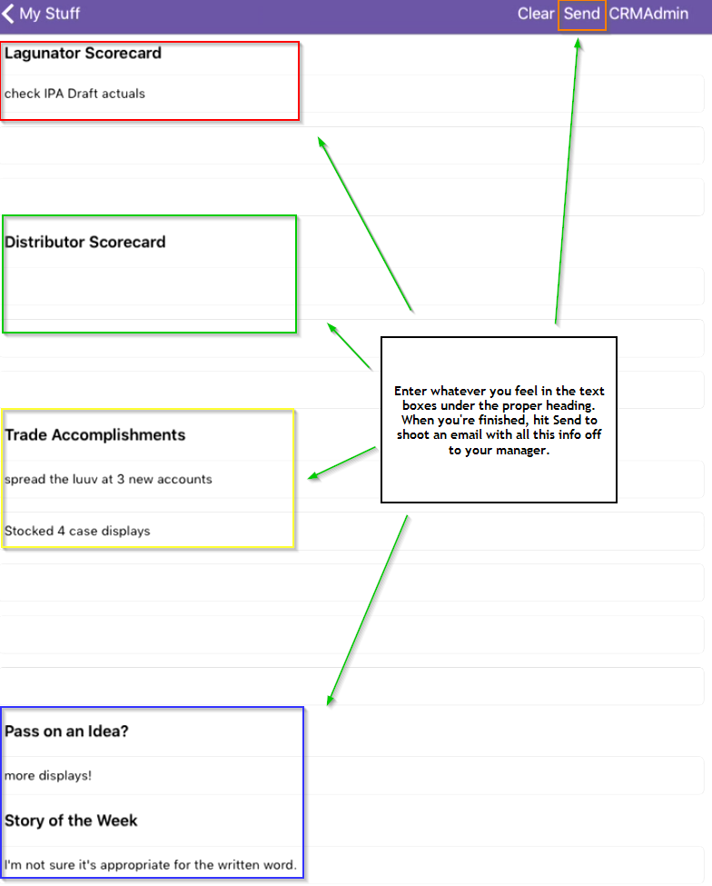

Once you’re finished filling out your High Five, hit Send to shoot an email containing your High Five to your manager.

# Distributor Communication



Selecting the Distributor Communication tab, you’ll be presented with three sections:

* Scorecards + YTD Numbers
* Recent Visits
* Action Items

Additionally, you’ll see the currently selected Distributor shown in the top-right corner.

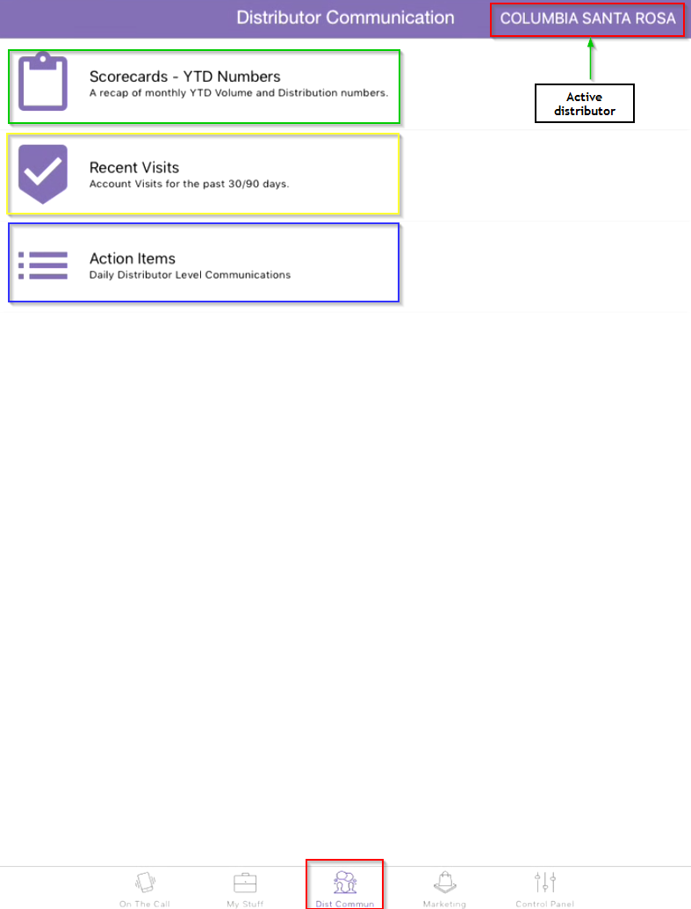

We’ll go into detail on each now.

## Selecting the Active Distributor

If you’ve already been using the On The Call tab, the distributor you chose on that tab will be shown as the Active distributor on the Distributor Communication tab.

You can also change the Active distributor on the Distributor Communication tab by pressing the distributor name in the top-right corner.

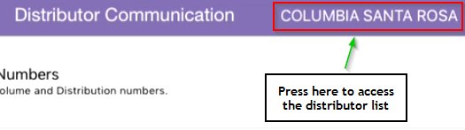

This will bring up the same distributor selection list as outlined in The Distributors Page (see this section for more details on selecting a distributor).

## Scorecards + YTD Numbers

## Recent Visits

The Recent Visits section is a list of all visits that have been made to accounts in the past 30 or 90 days – depending on which button is selected – which are served by the chosen distributor.

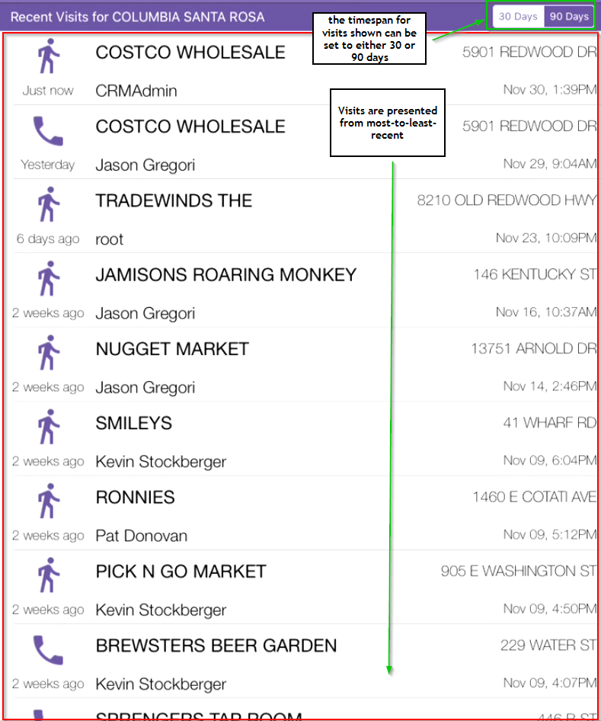

Pressing any visit will bring you to the Visit Overview and Entry page for that visit.

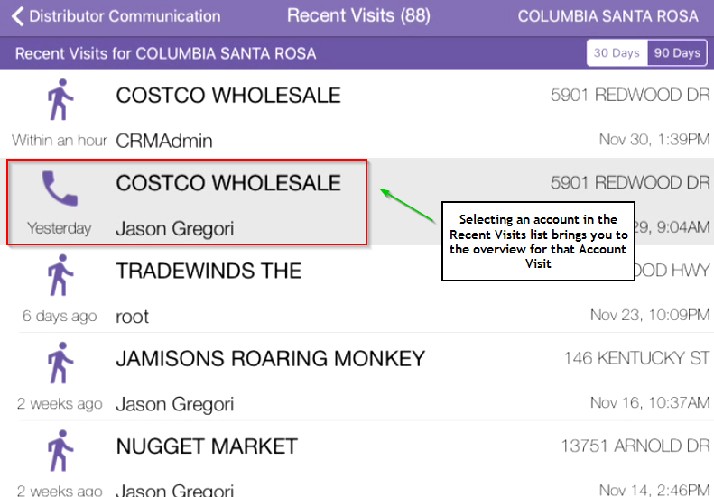

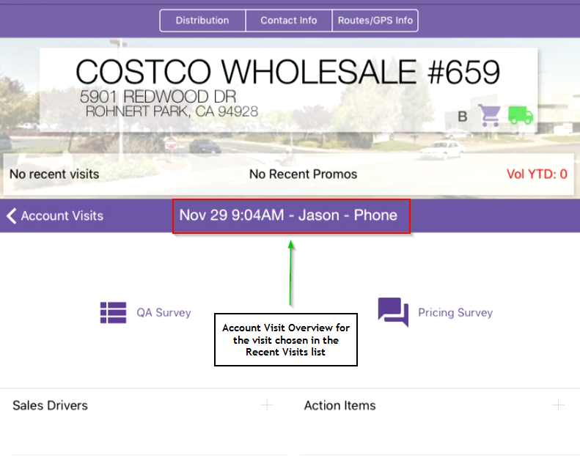

See Accessing Past Visits for more information on viewing and editing previously entered visits.

## Action Items

The Actions Items section is where all of the Action Items entered on Account Visits appear as a compiled list to be sent to the distributor.

The Action Items page is comprised of two main areas:

* The Header Bar, which contains buttons for various actions; and
* The List (not to be confused with Liszt), where all the Action Items are displayed

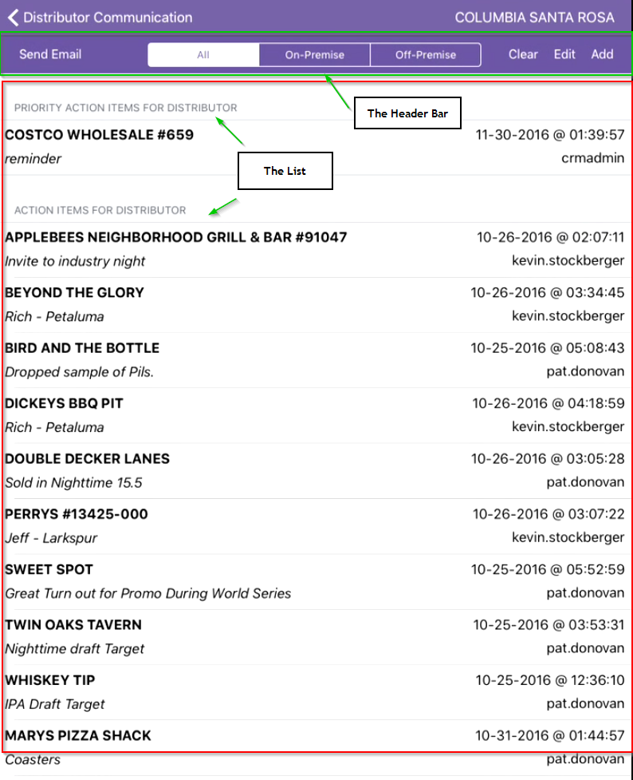

### The Action Items Header Bar



The Header Bar houses the functionality of the Action Items page. The behavior of each button in the bar is as follows:



Pressing this sends an email to the Active distributor, containing all of the Action Items displayed in The List (both regular and high priority Action Items).



These are filters to limit the Action Items shown in The List based on Premise type. Important to remember is that the Action Items sent to the distributor are affected by these filters (for example, if On-Premise is chosen, then only the On-Premise Action Items will be sent when “Send Email” is pressed).



These actions all affect The List, and so each requires a bit further discussion.

#### Clear

The Clear button removes all currently displayed Action Items from the Action Items list (this **does not delete** the Action Items, it just means they’ll no longer be available to send to the distributor). If you press the Clear button, you’ll be presented with the following warning:

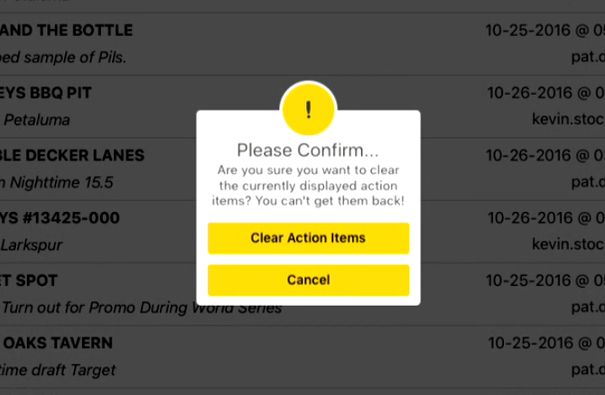

Press Cancel to return to The List, or press Clear Action Items to pass the point of no return. You’ve been warned.

#### Edit

Pressing Edit allows you to remove individual Action Items from The List. If you press the Edit button, you’ll see a horizontally bisected red circle appear next to every Action Item.

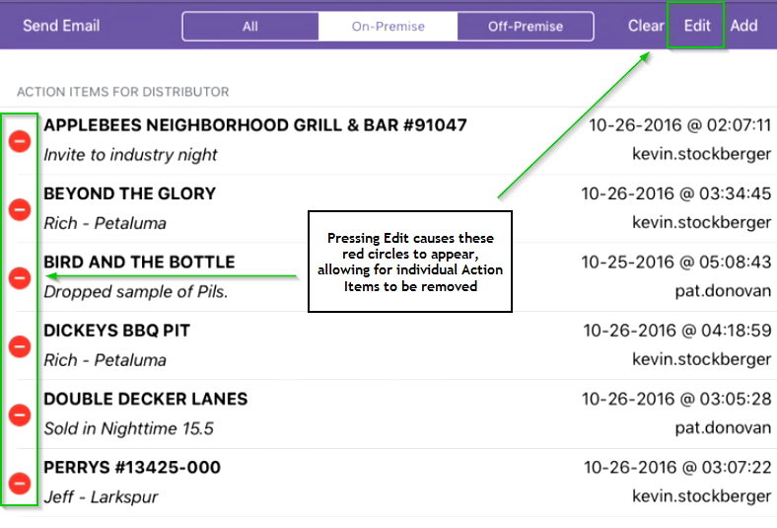

Press this circle if you dare, and the Action Item will be no more (on this list anyway, the Action Item will still be on the Account Visit).

#### Add

The Add button allows you to add a new Action Item directly to The List. Press Add, and you’ll be sent to a screen frighteningly similar to the Action Item entry screen you saw when entering Action Items on the Account Visit (for more on entering Action Items, see Adding Action Items).

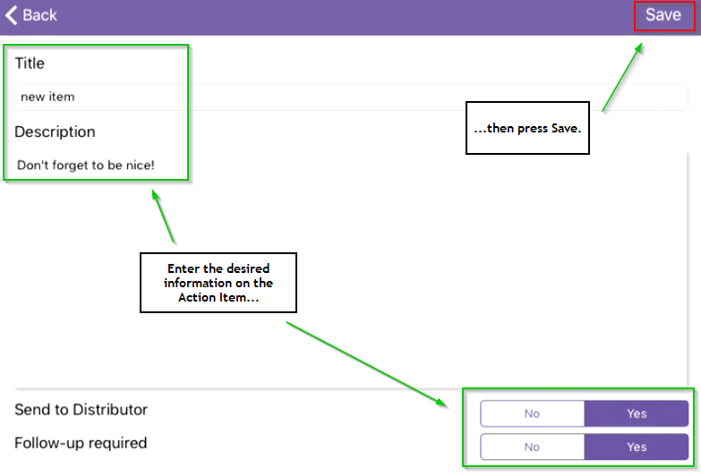

Enter the desired information on the Action Item and press Save. This will bring you back to the Action Items page, where you will see the newly entered item now appear in the Action Items list.

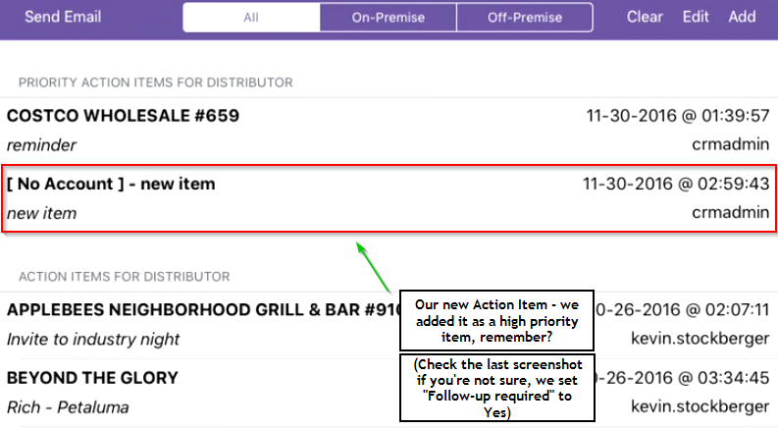

You’ll notice that we see **[ No Account ]** instead of an account name on the Action Item we just added. That’s because we added this Action Item directly on the Action Items page, and so it’s not associated with a particular account.

### The Action Items List

The Action Items List is broken into two sections: **High Priority** and **Regular Priority**.

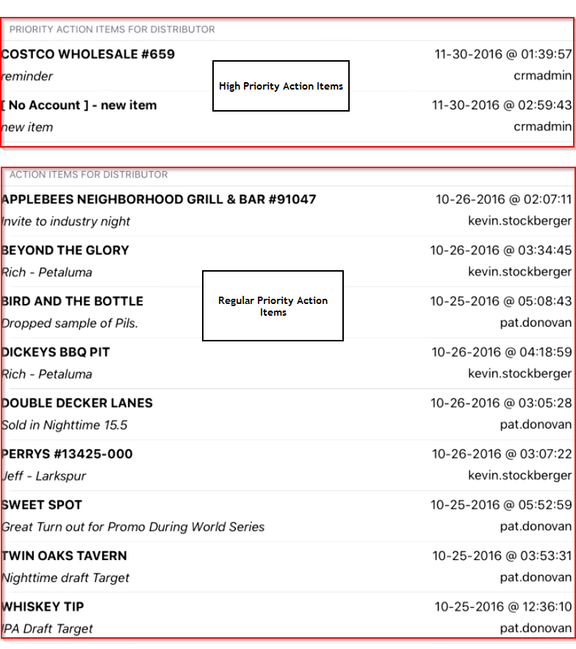

Action Items are displayed in the email we send to the distributor in the same order as they appear in this list, organized alphabetically by section, with high priority items at the top and the rest shown below.

Pressing on any Action Item in the list will bring you to the overview for that Action Item.

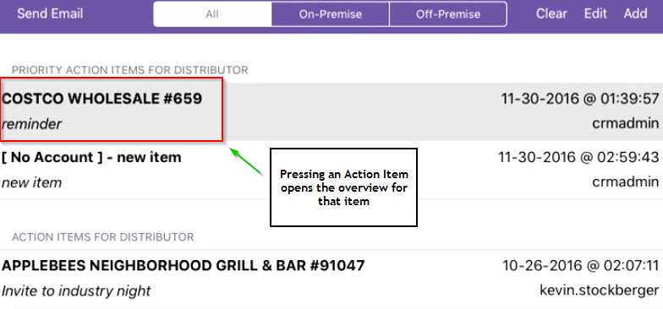

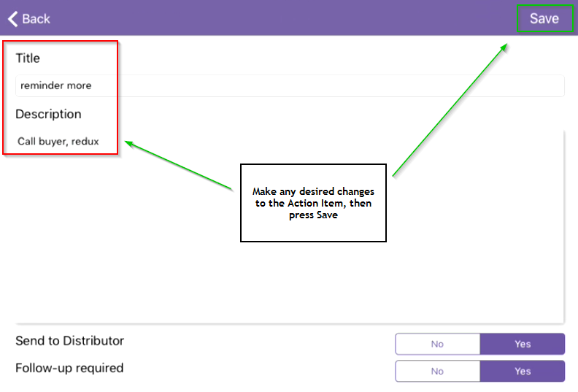

From here you can make any last-minute changes to the item before sending it to the distributor.

# Marketing



The Marketing tab is where you can find all the forms, sell sheets, and schwag items you need to keep your accounts engaged and in the loop.

There are four components of the Marketing tab:

* Off-site Event/Sponsorship Request Form
* Brewery Request Form
* Sell Sheets and Virtual Tastes
* Lagunitas Schwag

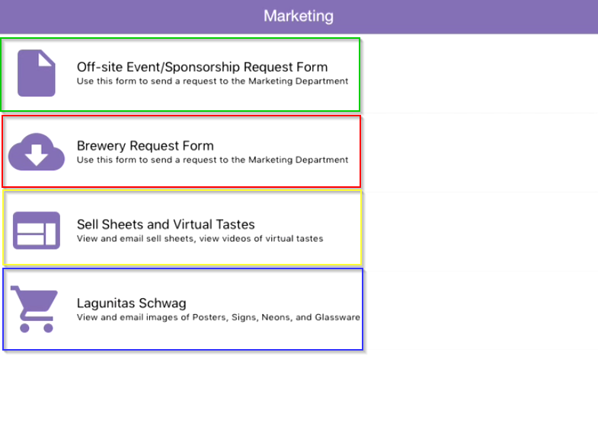

As with the other tabs, let’s cover each of these sections in more detail.

## Off-site Event/Sponsorship Request Form

Once this comes on, it’ll allow you to email the Marketing Department directly with an off-site event or sponsorship request.

## Brewery Request Form

This form allows you to send in a brewery visit request to give some luuv to those important accounts you cover. Requests can be made to any of the (as of now) 5 Lagunitas locations – Petaluma, Chicago, Azusa, Charleston, and Seattle – and a variety of discounts and parameters can be applied depending on how much luuv you wish to send.

After pressing the Brewery Request Form, you’ll reach the Lagunitas locations page.

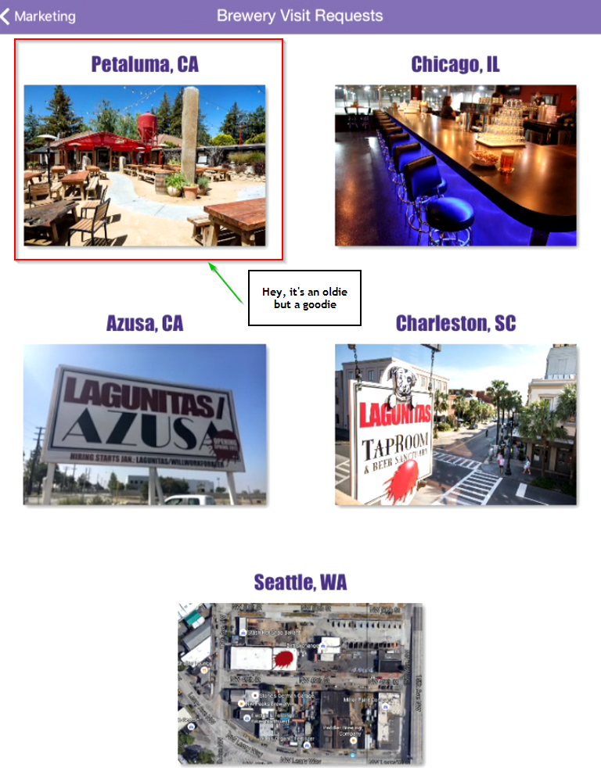

Choose the desired location for the visit (we’re sticking with Petaluma for this example). This’ll then bring up the Brewery Visit Request Form for that location.

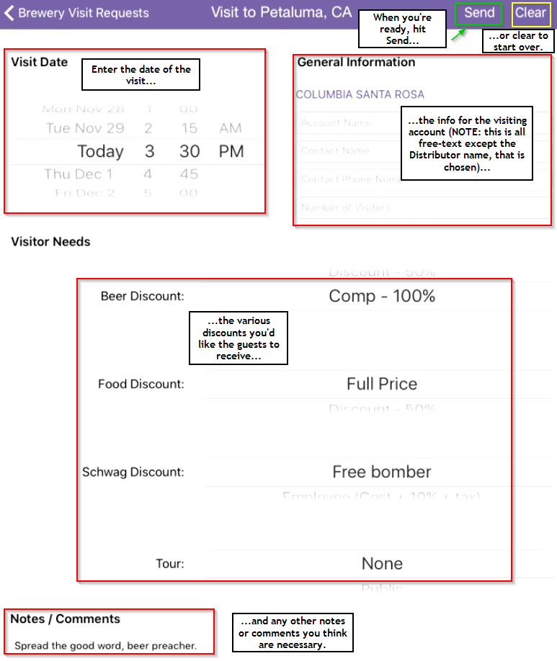

Fill out the form with the details of the account and the visit (date, requested discounts), and any notes you might have for the visiting account. When you’re all finished, hit Send to shoot an email to the on-site events crew.

## Sell Sheets and Virtual Tastes

This is where you can get the low-down on all our beers (including the Down Low). Go ahead and press the Sell Sheets button, you’re in for a treat.

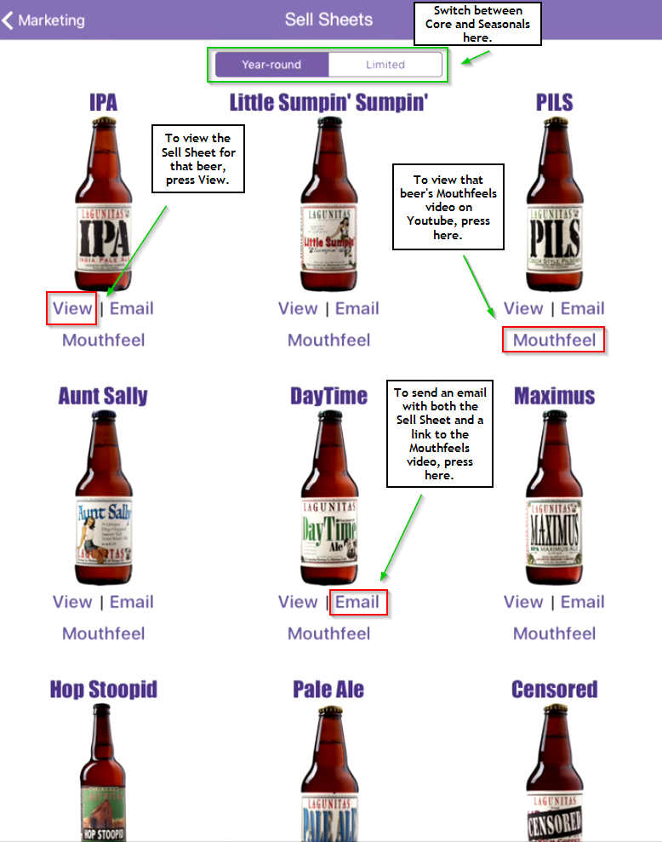

All the sell sheets we have are available here, along with a link to the corresponding beer’s Mouthfeels video on YouTube. The “Virtual Taste” is an email that you can send from here which automatically includes both a link to the Mouthfeels video and the sell sheet attached as a PDF. Pretty tasty if I do say so myself.

## Lagunitas Schwag

If you enter the Lagunitas Schwag section, you’ll be presented with groupings of all the schwag we have available – neons, posters, and wood signs, not to mention “other” (or everything weird and wacky that doesn’t fit in the other categories).

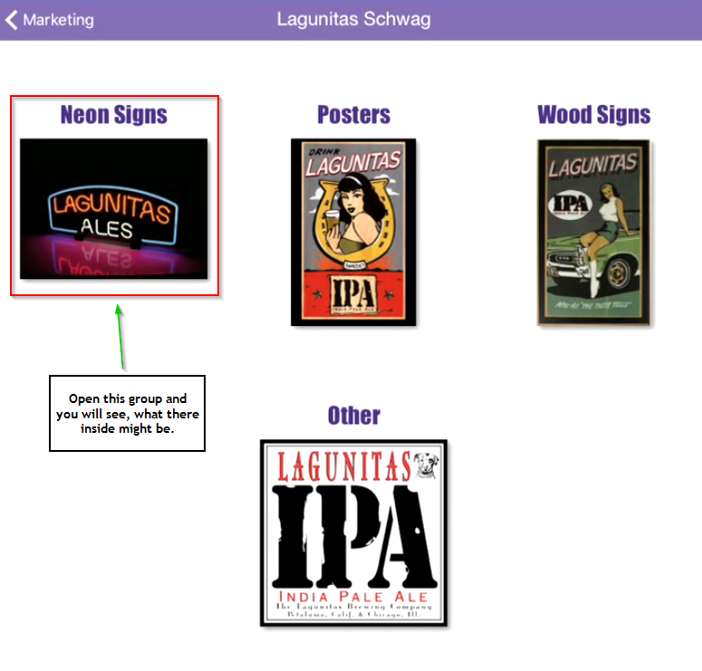

Clicking on any of these groupings will bring you to a page showing a variety of available merch within that group, pictures of which you can send out to an account – or anyone else for that matter, we won’t judge – by pressing the “Email” button underneath the corresponding item.

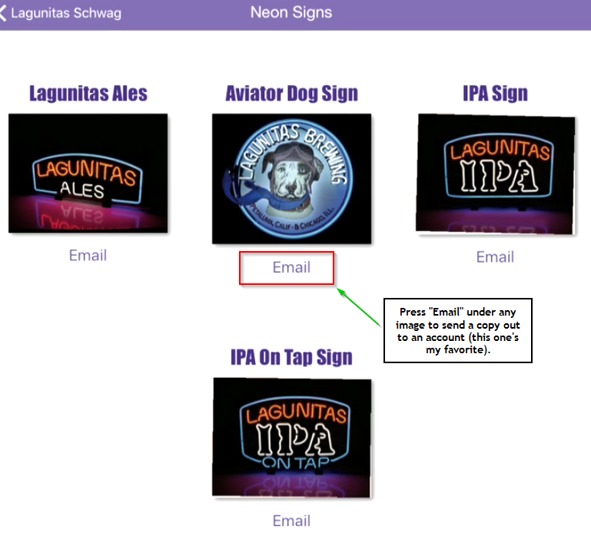

# Control Panel



You need in-app help? Gotta configure something? Head to the Control Panel.

## Help Desk

To send an email directly to the CRM Help Desk (hey, that’s me!), press the Help Desk button.

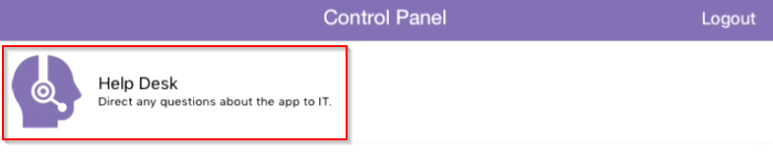

This’ll bring up an email where you can posit any questions, express any concerns, or report any bugs you find directly to us here in the IT department. The CRM2 and iOS versions are conveniently included on the email you send to help give us a head start in resolving whatever the issue might be.

## Logout

You’ll find the Logout button in the Control Panel. To logout, just press the Logout button and you’re free to go.

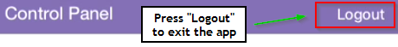

Speaking of logging out, I think we’ve reached the end of the help guide. Time for me to logout as well!

Cheers!